**FPT ACADEMY INTERNATIONAL**



## FPT – APTECH COMPUTER EDUCATION

**RAINWATER HARVESTING**

|  |  |  |  |
| --- | --- | --- | --- |
| **Center Name** | | FPT – Aptech – HCM2  Address: 590 Cach Mang Thang Tam, District 3, Ho Chi Minh City | |
| **Instructor** |  | Ms. Le Mong Thuy |  |
| **Class** |  | T1.2208.A0 |  |
| **Group** |  | 3 |  |
| **Group members** | | **Name** | **Student ID** |
|  |  | Tran Hong Duy Tu | Student1409139 |
|  |  | Vo Quang Trung | Student1407989 |
|  |  | Vo Van Suong | Student1407992 |
| **Duration** | Start date | 14th Nov 2021 |  |
| End date | 14th Dev 2021 |  |

**This is to certify that**

**Mr.:**

Tran Hong Duy Tu

Vo Quang Trung

Vo Van Suong

**has successfully designed & developed**

eProject: Rainwater Harvesting website

**Submitted by:**

Tran Hong Duy Tu

**Date of issue: 14-Nov-2022**

**Authorized Signature:**

**TABLE OF CONTENTS**

****FPT – APTECH COMPUTER EDUCATION 1****

****TABLE OF CONTENTS**** ****2****

****ACKNOWLEGMENT**** ****3****

****SYNOSIS**** ****3****

****PROBLEM DEFINITION**** ****3****

****CUSTOMER'S REQUIREMENTS SPECIFICATIONS (CRS) 4****

****Business/Project Objective**** ****4****

****Hardware/ Software Requirements**** ****5****

****SCOPE OF THE WORK (IN BRIEF) 6****

****Architecture and design of the system 7****

****Diagram of the website 8****

****TASK SHEET REVIEW 1 9****

****SITE MAP 10****

****MOCK OF THE WEBSITE 1********1****

***1. Homepage 1******1***

***2. Product 1******2***

***3. Blog 1******3***

***4. About Us 1******4***

***5. Contact US 1******5***

***6. Service 1******6***

***7. Sign In/ Sign Up 1******7***

****TASK SHEET REVIEW 2 18****

WEBSITE DESCRIPTION ****1********9****

RESPONSIVE****28****

[****JAVASCRIPT DESCRIPTION****](#Javascript) ****30****

****TASK SHEET REVIEW 3**** ****47****

# ACKNOWLEGMENT

On behalf of team members. I would like to thank everyone who supported my team to successfully complete this eProject report. Especially, our teacher, she has supported us a lot since we started studying at FPT Aptect. With this eProject, she guided us very meticulously, enthusiastically and strictly. With her guidance, we were able to successfully complete this project. Besides, I also want to thank all the team members, each of whom worked hard to complete the eProject in earnest during the month of working together. Finally, our group would like to say thank you to my classmates and family for sharing and creating for the group the best environment to focus on the project, motivating the members to achieve their goals.

# SYNOSIS

# The goal of the eProject is that we need to create a website that meets all the requirements of the client, Rainwater Harvesting. Rainwater Harvesting is an website provide for the one who want to know about the advantage of collecting, storing and using rainwater. They always give the various ways to have the experiences with Rainwater Harvesting easily. The main goal of this website is to reach customers who want to improve their own life environment and also for the better world when many people have known about the Rainwater Harvesting. In addition, the products for Rainwater Harvesting also provide detail in website . The better life for everyone with Rainwater Harvesting is always the top goal of us.

# PROBLEM DEFINITION

The Web site is to be created based on the following requirements.

1. The home page about the description/images about various rainwater

harvesting techniques should be provided. If user clicks on the same,

navigational link must be available.

2. There should be categories providing details about rainwater harvesting in

various areas like

a. Residential area

b. Commercial area

3. Under the categories mentioned above, there should be the various

products available (well explained about them) as well other techniques

that can be applied.

4. The site should also list and explain various facts related and methods that

are applied for harvesting

5. There should be a section which will educate people on how to effectively

make use of harvested water

6. Also include a section which will provide details on various latest

developments in the field of rainwater harvesting

7. Also each link must be properly hyperlinked; images must be used wherever

necessary.

8. Contact us page: contact us details with location should be displayed using

GeoLocation API (eg. GoogleMaps).

# CUSTOMER'S REQUIREMENTS SPECIFICATIONS (CRS)

**Client: Rainwater Harvesting**

### Business/Project Objective:

Rainwater Harvesting is an website provide for the one who want to know about the advantage of collecting, storing and using rainwater. They always give the various ways to have the experiences with Rainwater Harvesting easily. The main goal of this website is to reach customers who want to improve their own life environment and also for the better world when many people have known about the Rainwater Harvesting. In addition, the products for Rainwater Harvesting also provide detail in website.

You are supposed to create a website for them with the below mentioned requirement specifications.

The website is to be developed for the Windows Platform using HTML5, JavaScript and Geolocation. The site should work well in all leading browsers including Chrome, IE, Firefox etc.

**Input to the system:**

- Home, Rainwater harvesting, Methods, Development, Contact.

**Output from the system:**

- The website should be able to provide a brief introduction to the project in the homepage

- Show list of rainwater harvesting tools

- The location of the company in the Contact page.

- Displays frequently asked questions and allows users to email the company directly

**Process**:

* + - * Validate data input from users.

**Expected delivery date:** 14-Dev-2022.

**List of deliverables:**

- Document Word, PDF.

- User Guide.

- Source code.

### Hardware/ Software Requirements:

* **For developer**

**Hardware**

* + Intel Pentium 4 processor or higher
  + 01 Gigabytes of RAM or higher

**Software**

* + Windows 7 OS or higher
  + Adobe Dreamweaver
  + Web browsers such as IE, Chrome or Firefox are supporting HTML5, CSS3 and Javascript.
* **For web users**

**Hardware**

* + Intel Pentium 4 processor or higher
  + 512 Megabytes of RAM or higher

**Software**

* + Windows XP OS or higher
  + Web browsers such as IE, Chrome or Firefox are supporting HTML5, CSS3 and Javascript

# 

# SCOPE OF THE WORK (IN BRIEF)

After a long and detailed discussion, our group has decided to create a website contain the following webpages:

1. ***Homepage:*** There is the description, images about various rainwater harvesting techniques.
2. ***Rainwater Harvesting:*** There is providing details about rainwater harvesting in various areas like residential, commercial area and introduce about the products used for rainwater harvesting.
3. ***Methods:*** There is give various ways to do rainwater harvesting appropriate for many scales.
4. ***Developments:*** There is tell about the history of rainwater harvesting after many dynasty of a lot of countries.
5. ***Contact:*** There is providing the ways to contact us in social media like Gmail, Phone number and Address.

# ARCHITECTURE AND DESIGN OF THE SYSTEM

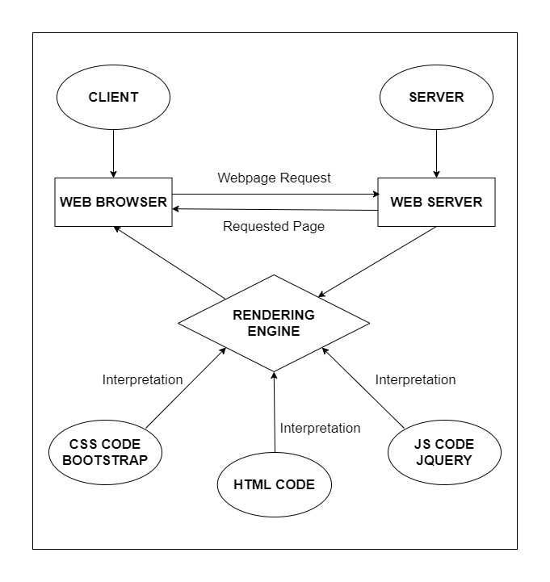

# DIAGRAM OF THE WEBSITE

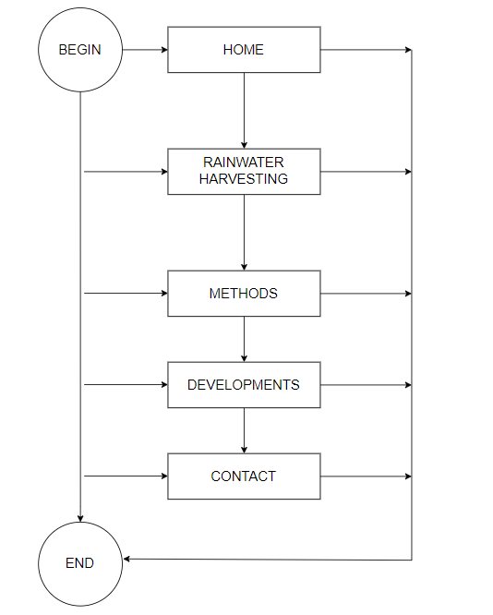



# TASK SHEET REVIEW 1

|  |  |  |  |  |  |  |  |
| --- | --- | --- | --- | --- | --- | --- | --- |
| **Project Ref. No.:**  **eP/Advertisement Portal Management**  **System/01** | | **Project Title:** | **Activity Plan Prepared By:** | **Date of Preparation of Activity Plan:** | | | |
| **Sr.**  **No.** | **Task** | **Actual**  **Start**  **Date** | **Actual Days** | **Team**  **Mate Names** | **Status** |
| 1 | Problem Statement | RAINWATER  HARVESTING | Tu | 14-Nov-22 | 1 | Tu | Completed |
| 2 | Analysis of Rainwater Harvesting requirements about the website | 14-Nov-22 | 1 | Tu | Completed |
| 3 | The scope of the work (in brief) | 14-Nov-22 | 1 | Trung | Completed |
| 4 | Architecture and design of the system | 14-Nov-22 | 1 | Trung | Completed |
| 5 | Diagram of the website | 14-Nov-22 | 1 | Suong | Completed |
| 6 | Task Sheet | 14-Nov-22 | 1 | Suong | Completed |

|  |  |
| --- | --- |
| **Date:** | |
| Signature of Instructor:  **Ms. Le Mong Thuy** | Signature of Team Leader:  **Tran Hong Duy Tu** |

# SITE MAP

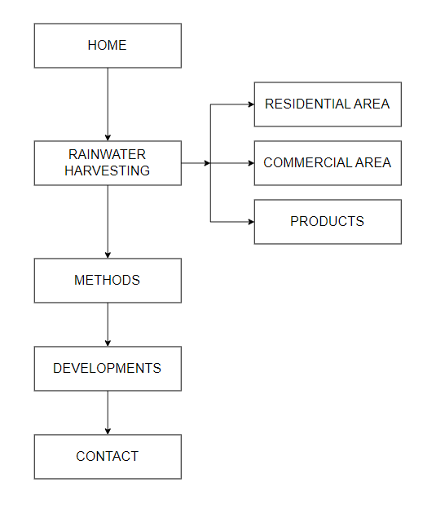

# MOCK OF THE WEB SITE

**1.Homepage:**

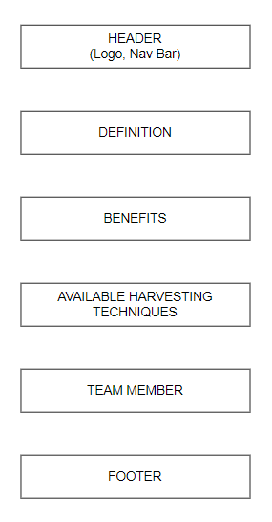

**2.Rainwater Harvesting (Residential Area):**

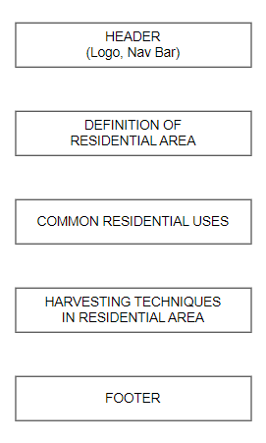

**3.Rainwater Harvesting (Commercial Area):**

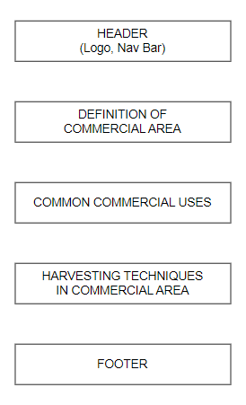

**4.Rainwater Harvesting (Products)**

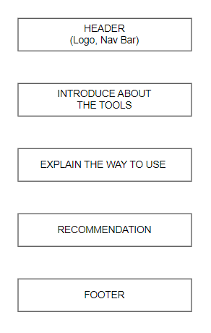

**5.Methods:**

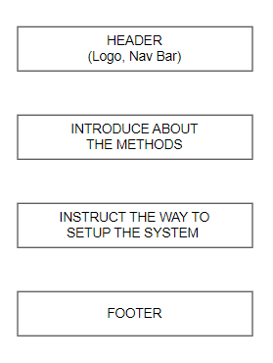

**6.Developments**

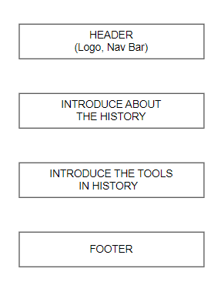

**7.Contact**

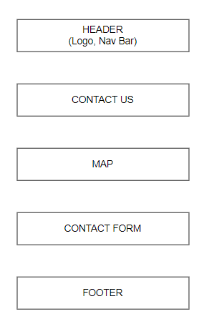

1. **Home**:
   1. Description:

This is the main page to explain and present what is the rainwater harvesting (definition, benefits, techniques, …).

* 1. Screenshot:

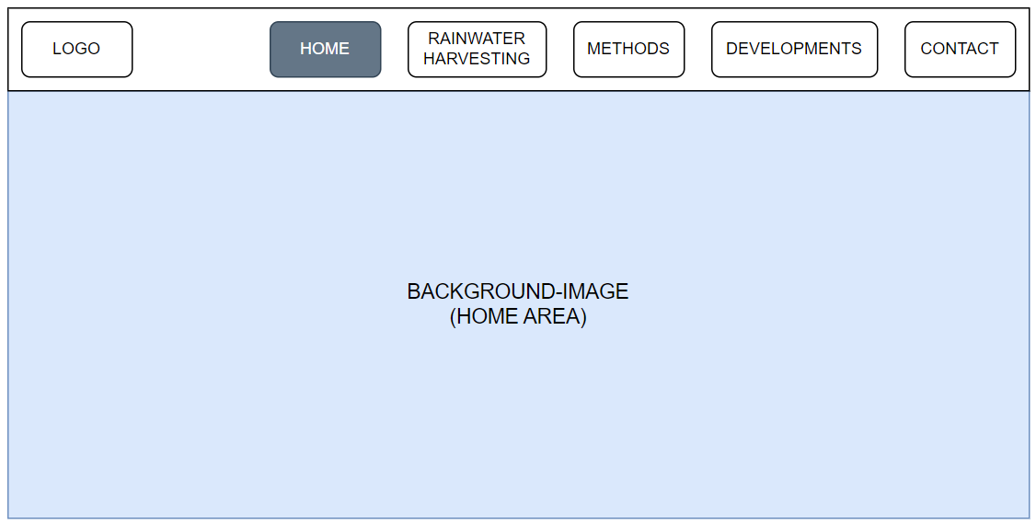

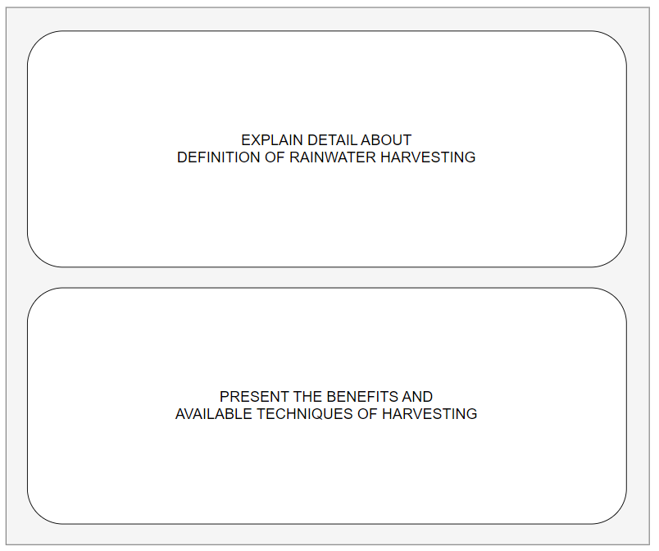

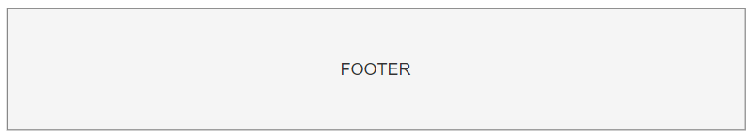

1. **Rainwater Harvesting (Residential Area)**:
2. Description:

This page will present what the residential area is in the detail way and gives many choices to setup the system of rainwater harvesting appropriate to residential scale.

1. Screenshot:

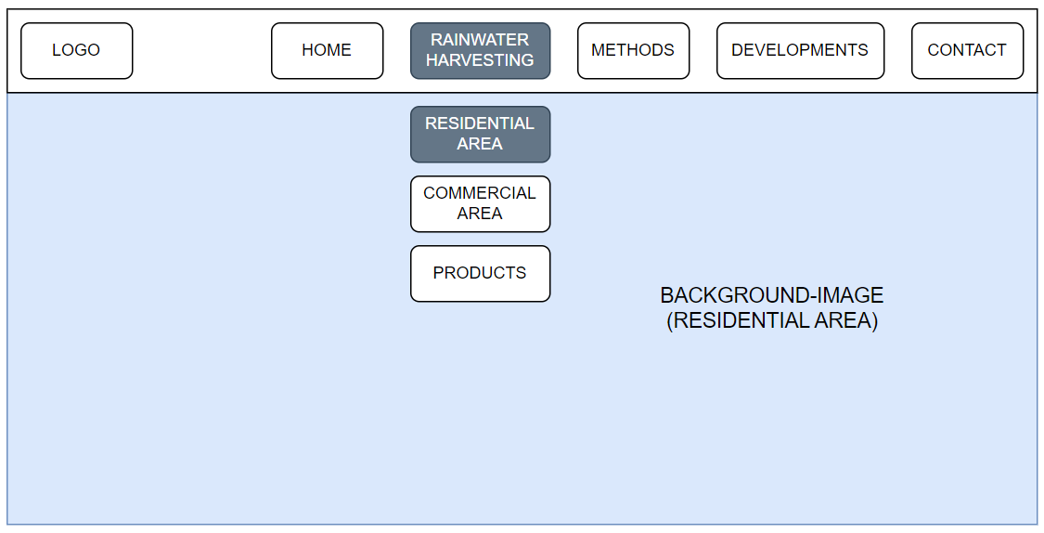

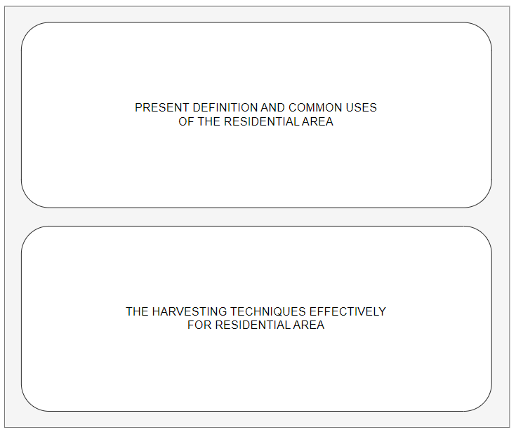



1. **Rainwater Harvesting (Commercial Area)**:

a. Description:

This page will present what the commercial area is in the detail way and gives many choices to setup the system of rainwater harvesting appropriate to commercial scale.

1. Screenshot:

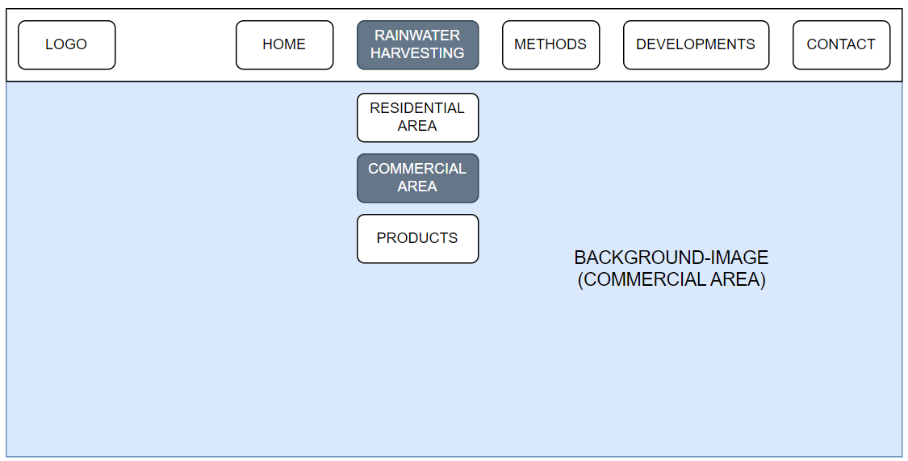

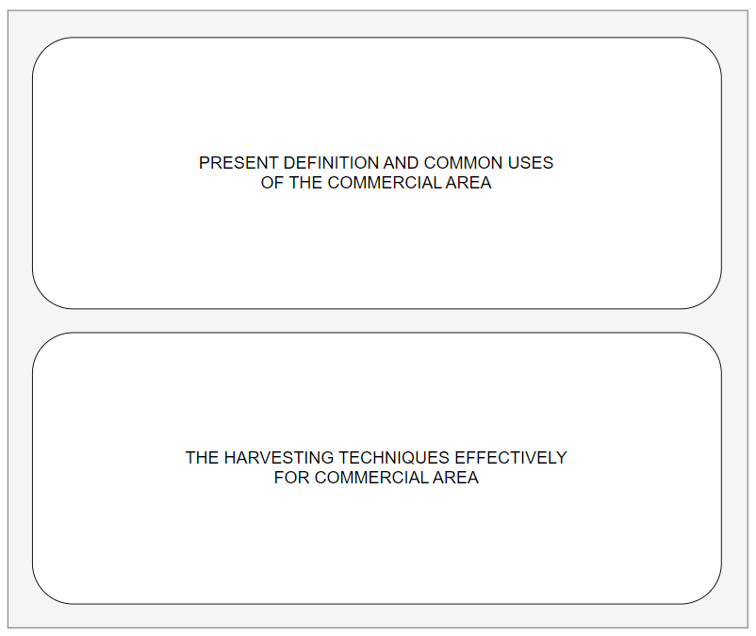



1. **Rainwater Harvesting (Products)**:
2. Description:

This page will display the products used for rainwater harvesting and describe the ways to use them effectively.

1. Screenshot:

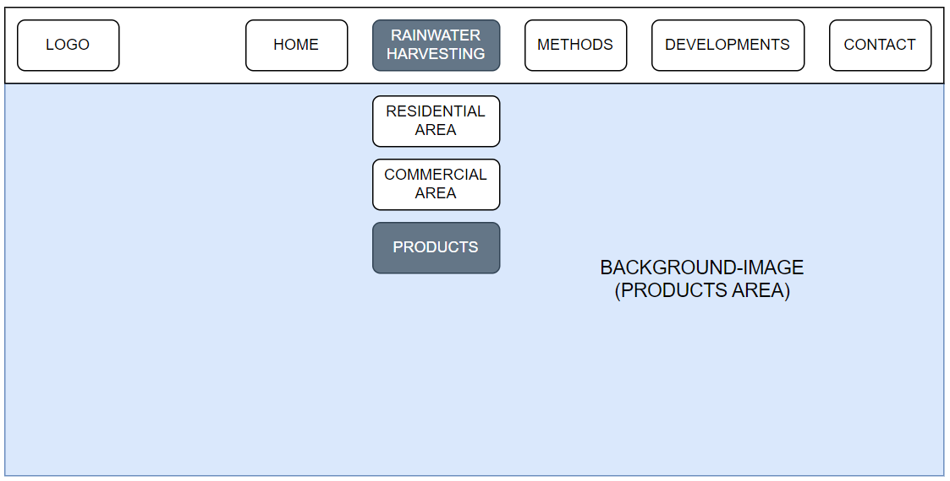

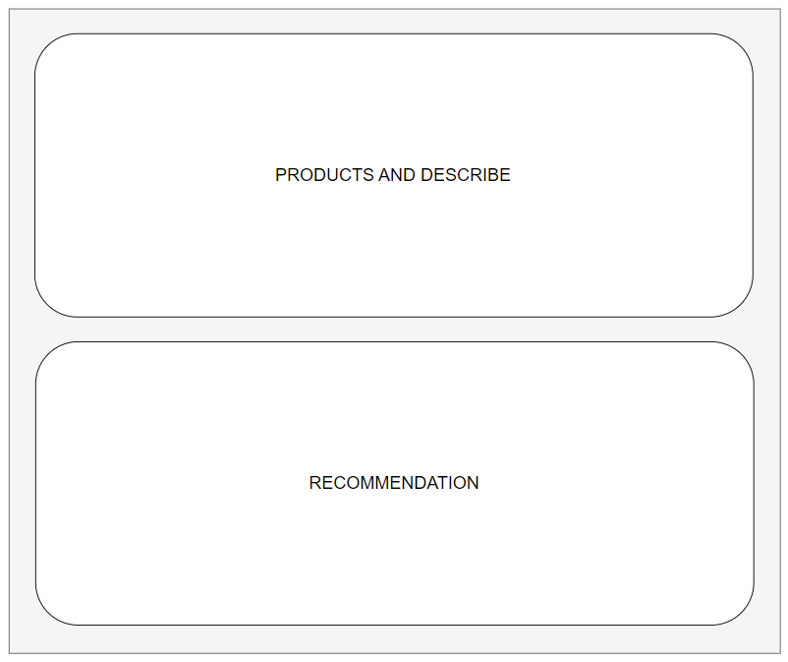

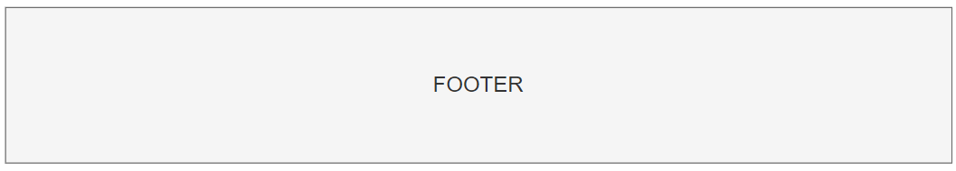

1. **Methods**:
2. Description:

This page will present about the methods to setup a successfully system and use water after rainwater harvesting efficiently.

1. Screenshot:

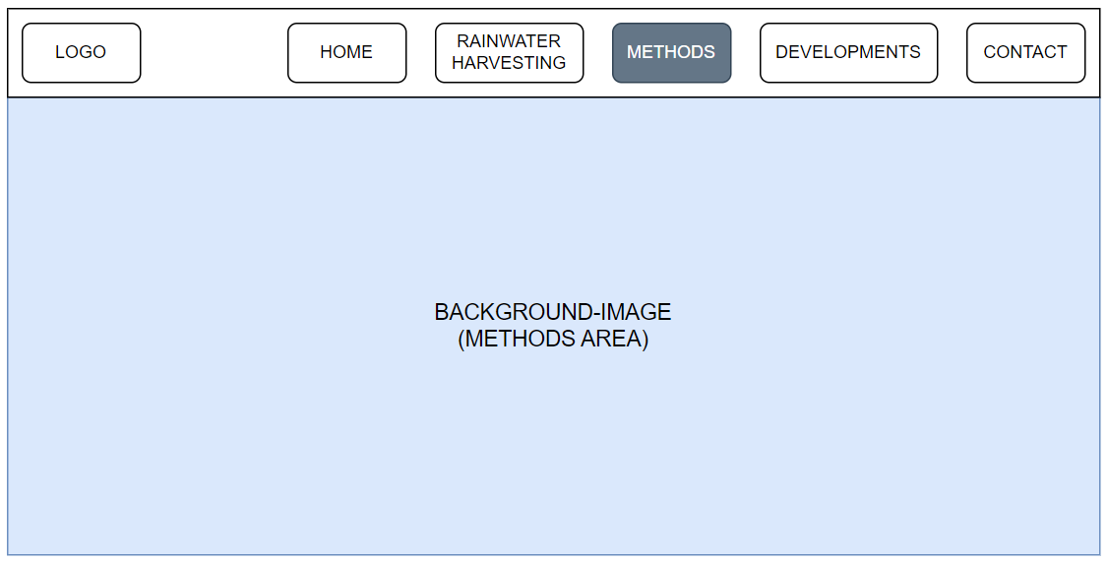

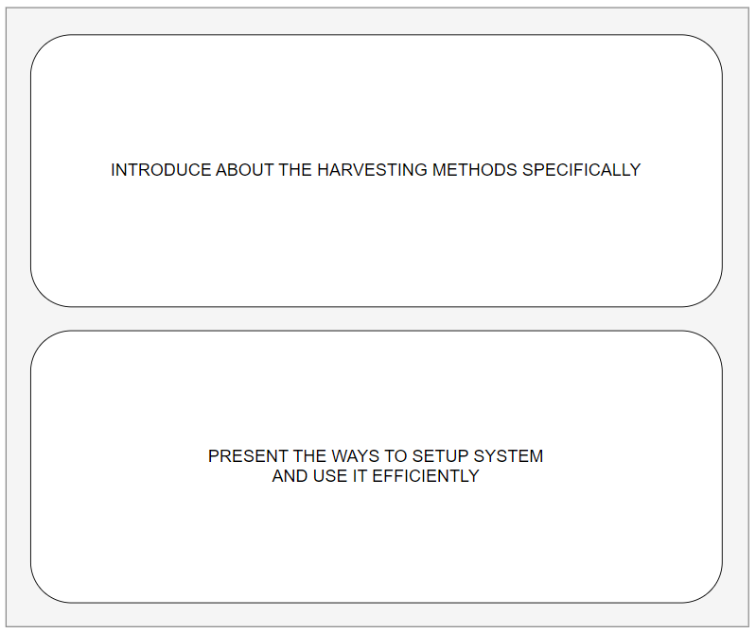



1. **Developments**:
2. Description:

This page will show about the history of rainwater harvesting’s development through many dynasty.

1. Screenshot:

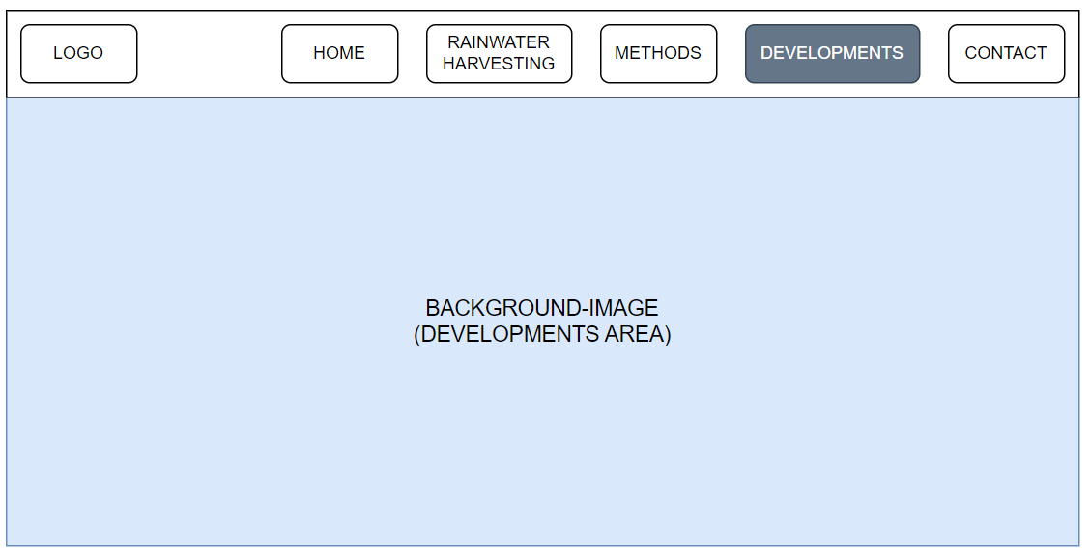

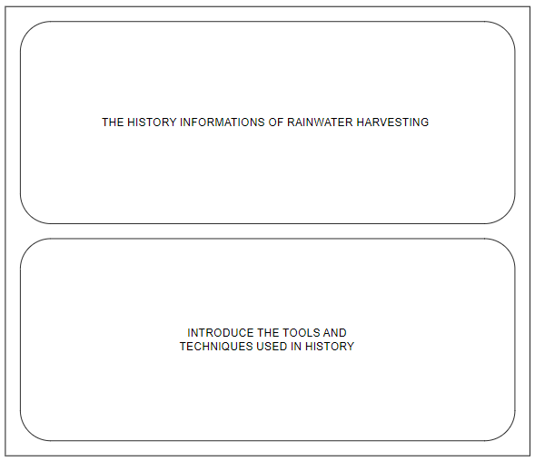



1. **Contact**:
2. Description:

This page will give many ways to contact us included social medias, phone number, email and map.

1. Screenshot:

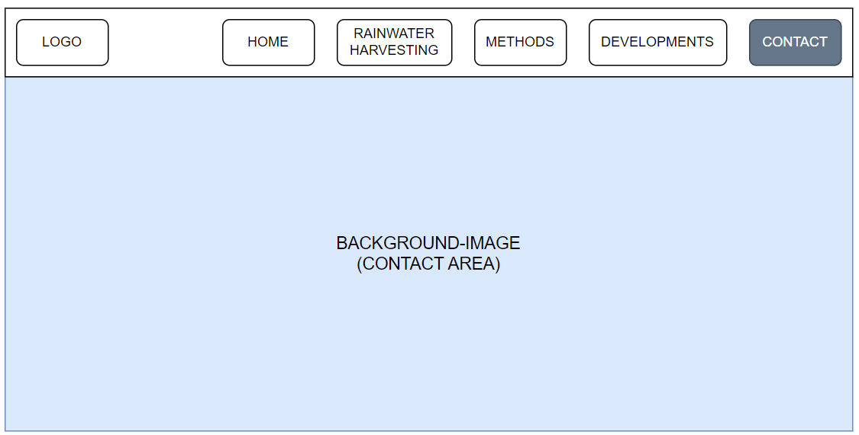

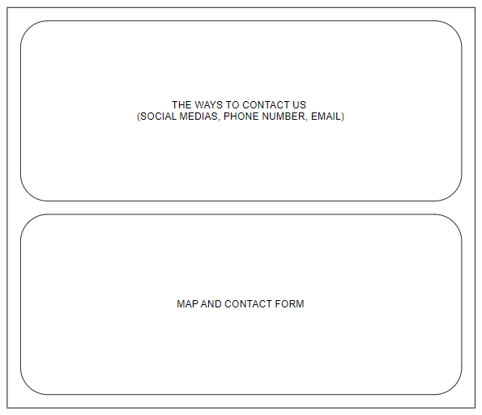

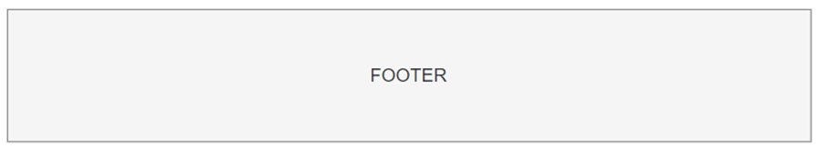

# TASK SHEET REVIEW 2

|  |  |  |  |  |  |  |  |
| --- | --- | --- | --- | --- | --- | --- | --- |
| **Project Ref. No.:**  **eP/Advertisement Portal Management**  **System/01** | | **Project Title:** | **Activity Plan Prepared By:** | **Date of Preparation of Activity Plan:** | | | |
| **Sr.**  **No.** | **Task** | **Actual**  **Start**  **Date** | **Actual Days** | **Team**  **Mate Names** | **Status** |
| 1 | Site Map | RAINWATER  HARVESTING | Tu | 16-Nov-22 | 1 | Tu | Completed |
| 2 | Mock of the website | 16-Nov-22 | 2 | Trung | Completed |
| 3 | Task sheet | 16-Nov-22 | 2 | Suong | Completed |

|  |  |
| --- | --- |
| **Date:** | |
| Signature of Instructor:  **Ms. Le Mong Thuy** | Signature of Team Leader:  **Tran Hong Duy Tu** |

# WEBSITE DESCRIPTION

1. **Home:**
2. Description

Home page displays following information:

- The definitions, benefits of rainwater harvesting.

- Common rainwater harvesting techniques.

- Some information about the creators.

1. Screen shot

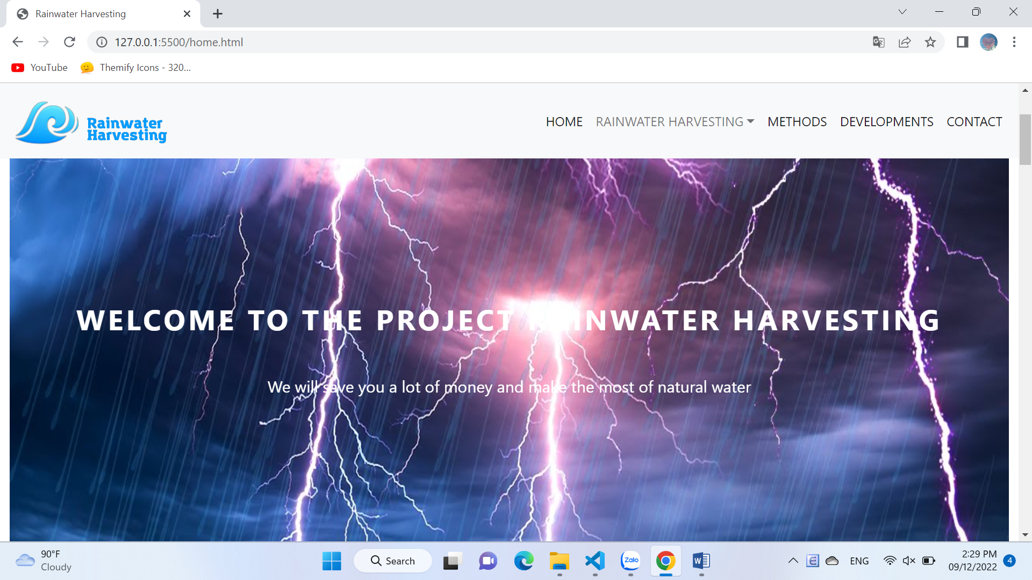

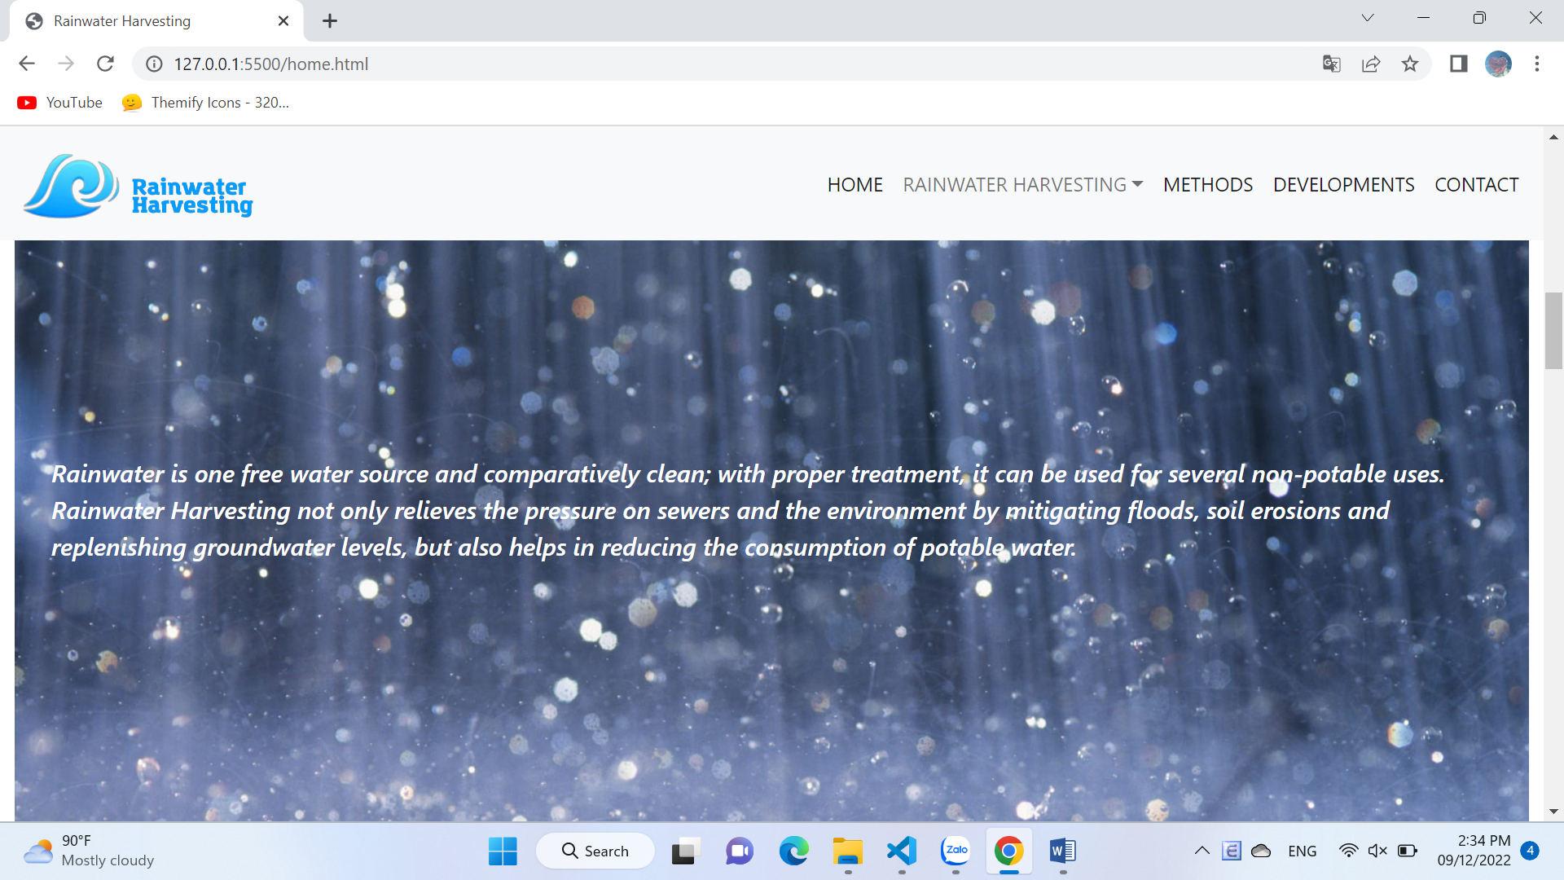

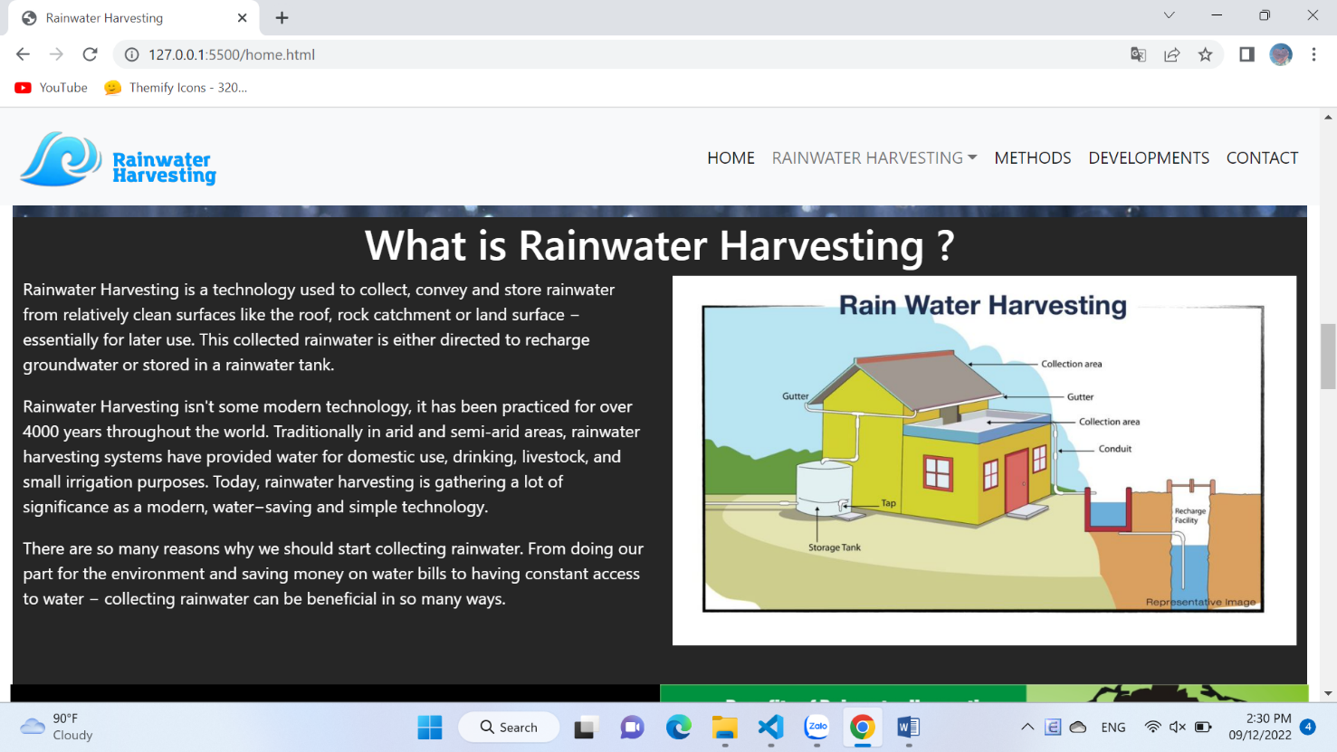

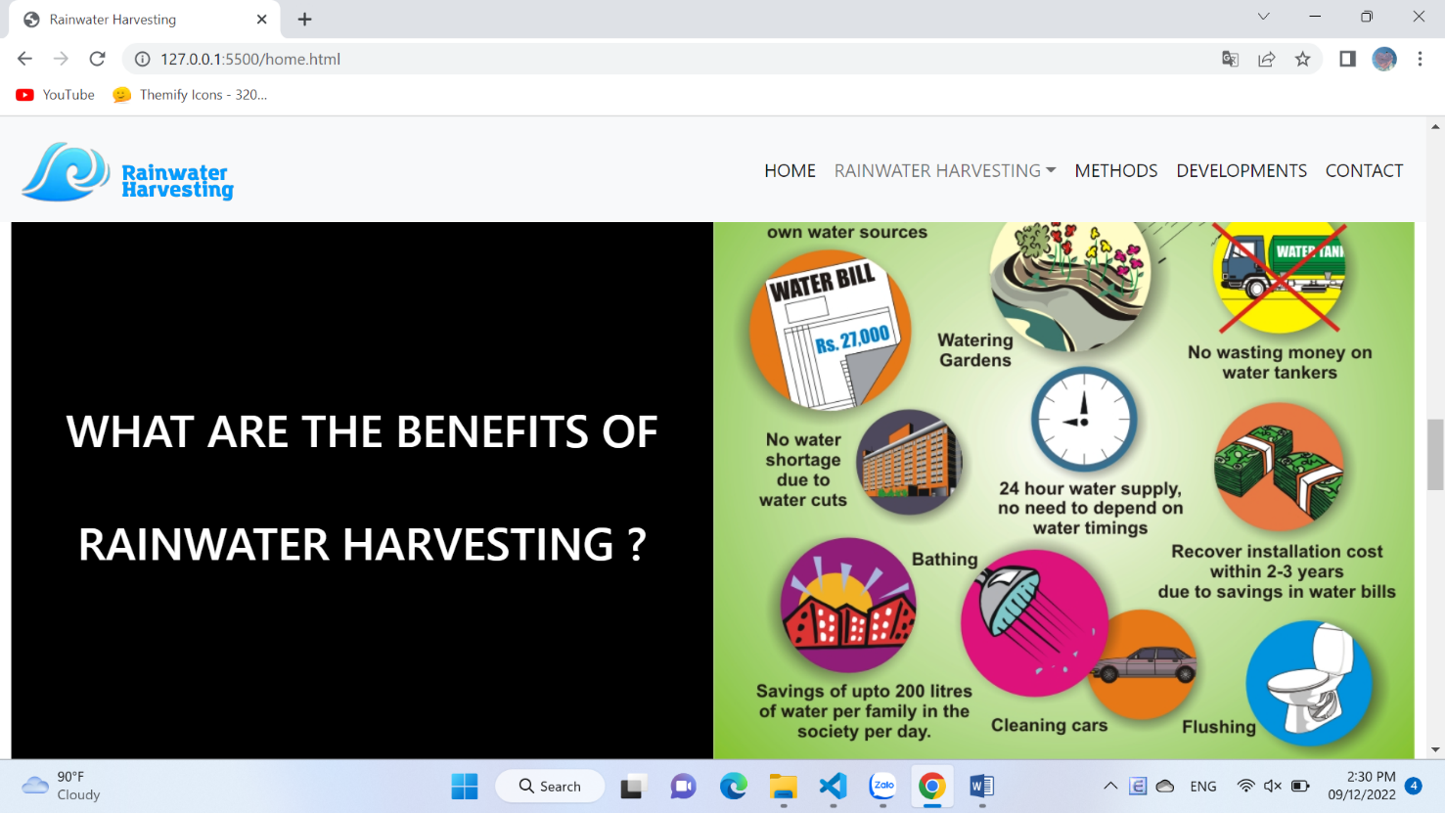

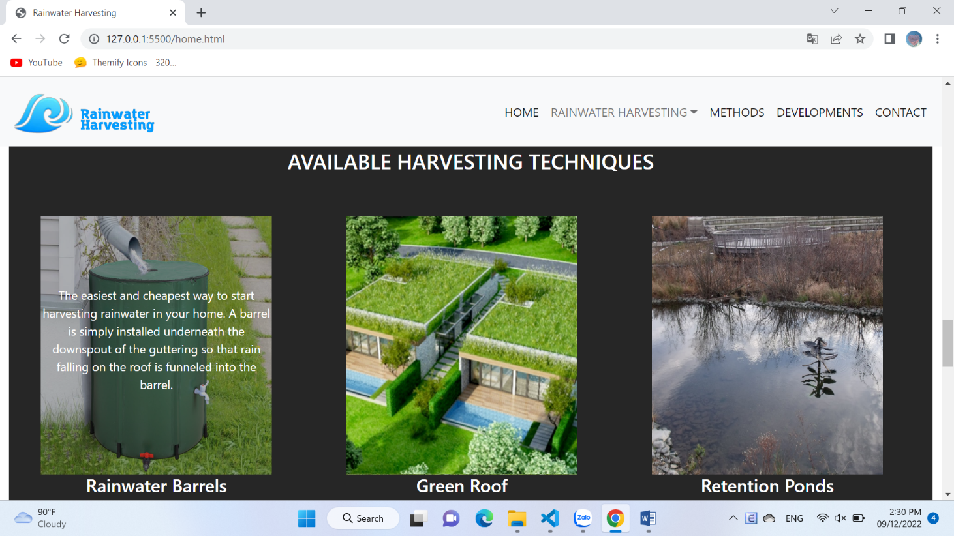

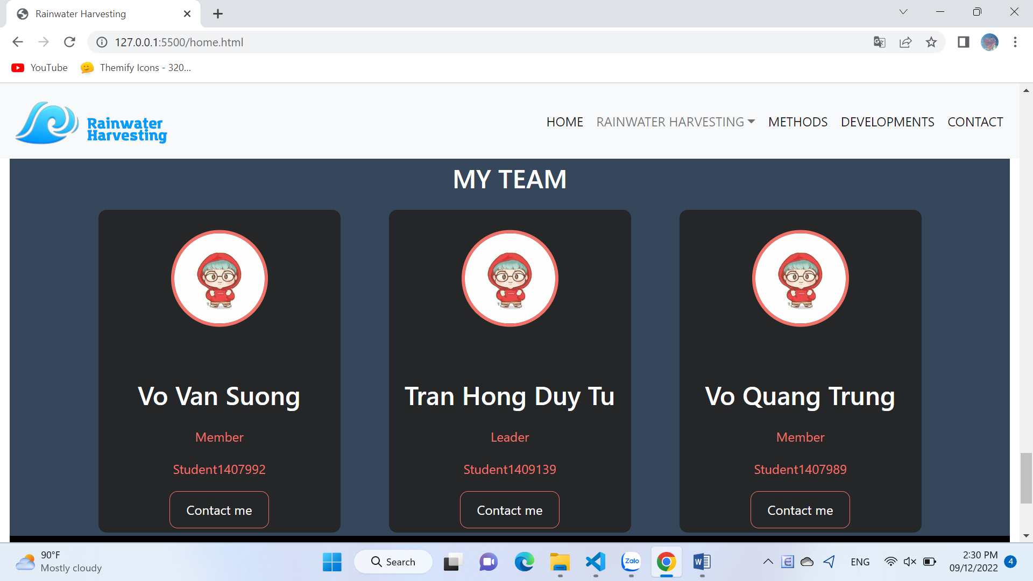

1. **Rainwater Harvesting (Residential Area):**
2. Description

This product page displays following information:

- All product that being sold at Harvel Electric (LED & Lighting, FANs, Cables & Wires, Switches & Automation, Protection Devices, Appliances), when click on quick view item, it will show the detail of that item.

- Products can be compared with products of the same category

- Menu filter to easily find items based on categories.

- Product can sort by price and by name.

1. Screen shot

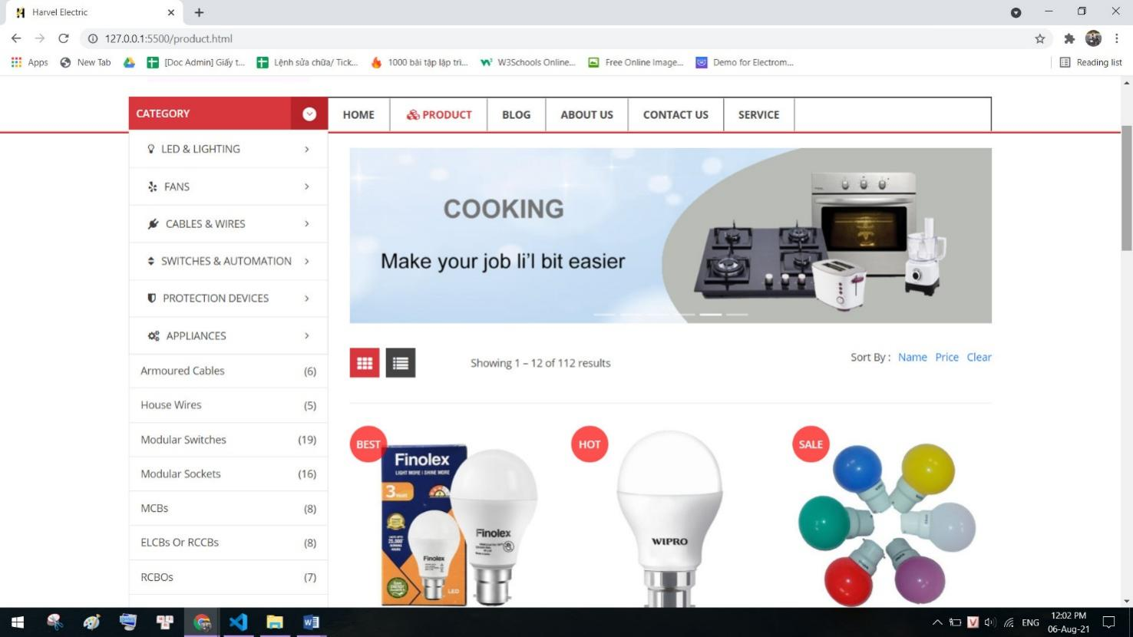

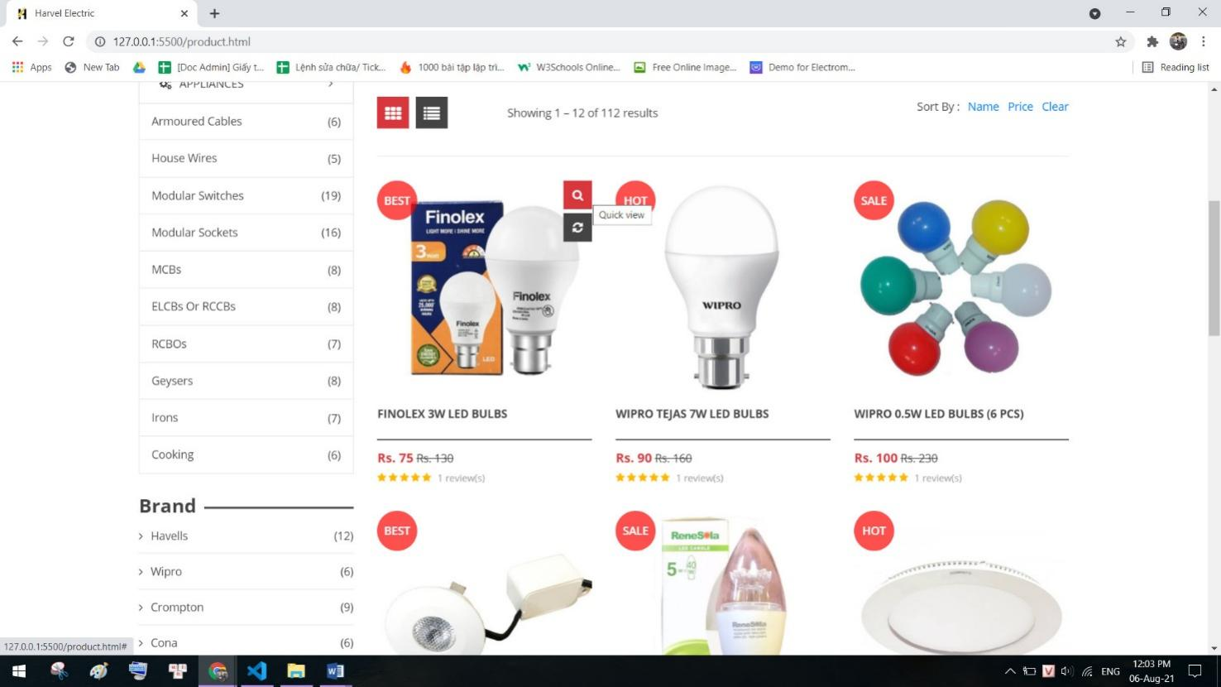

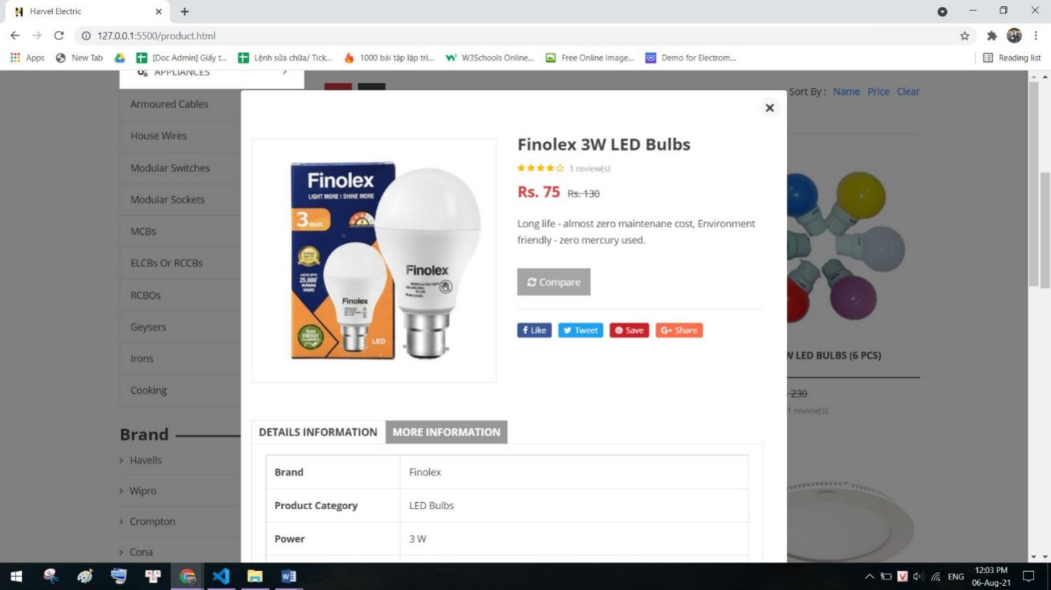

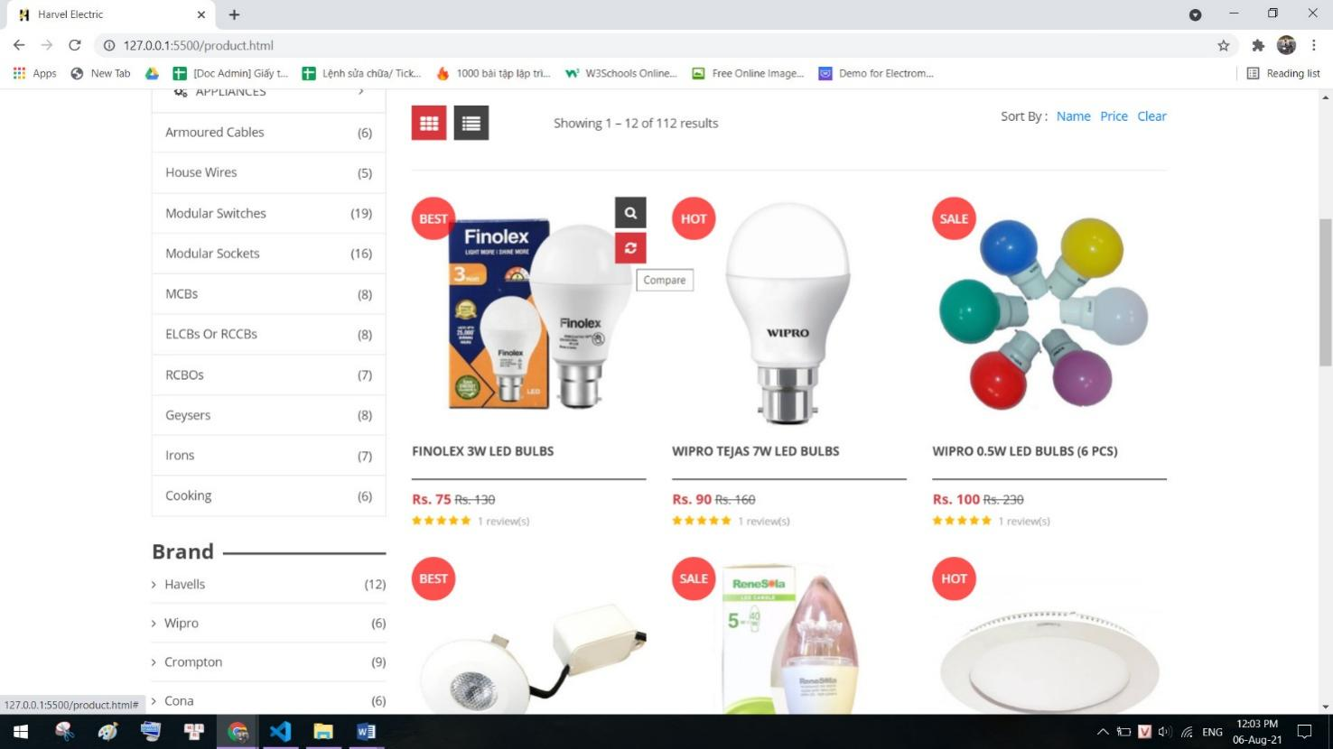

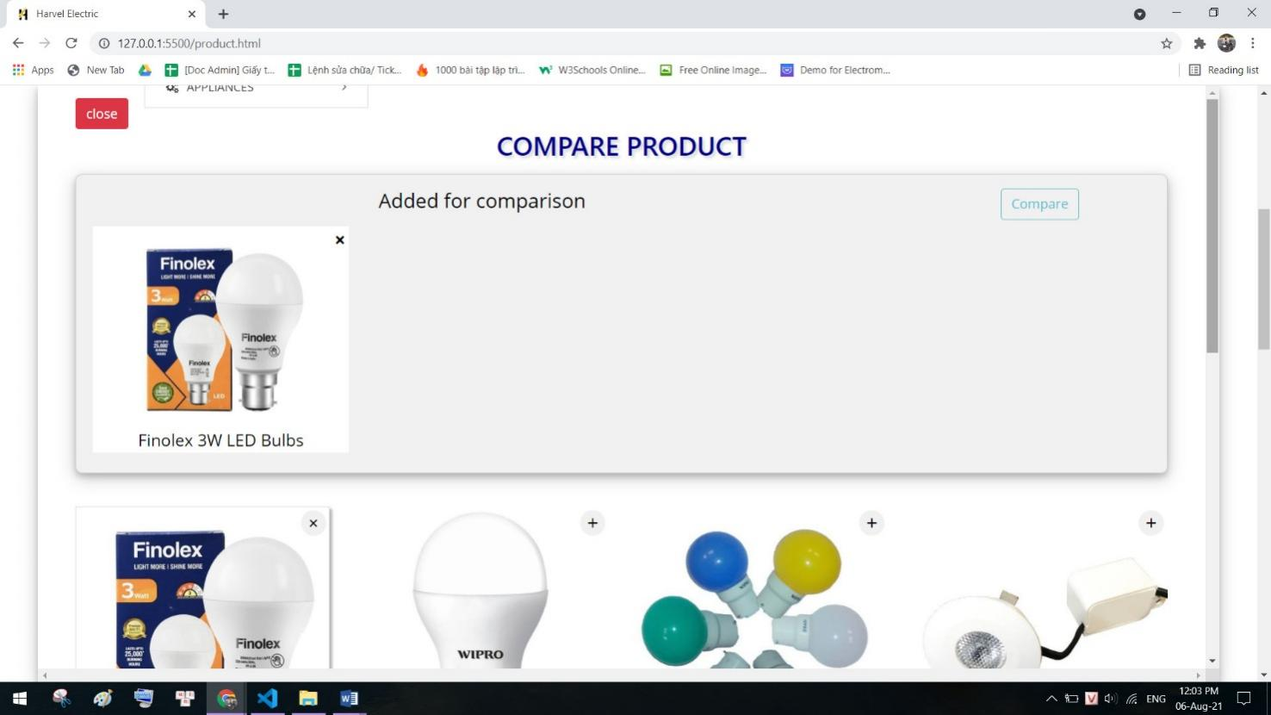

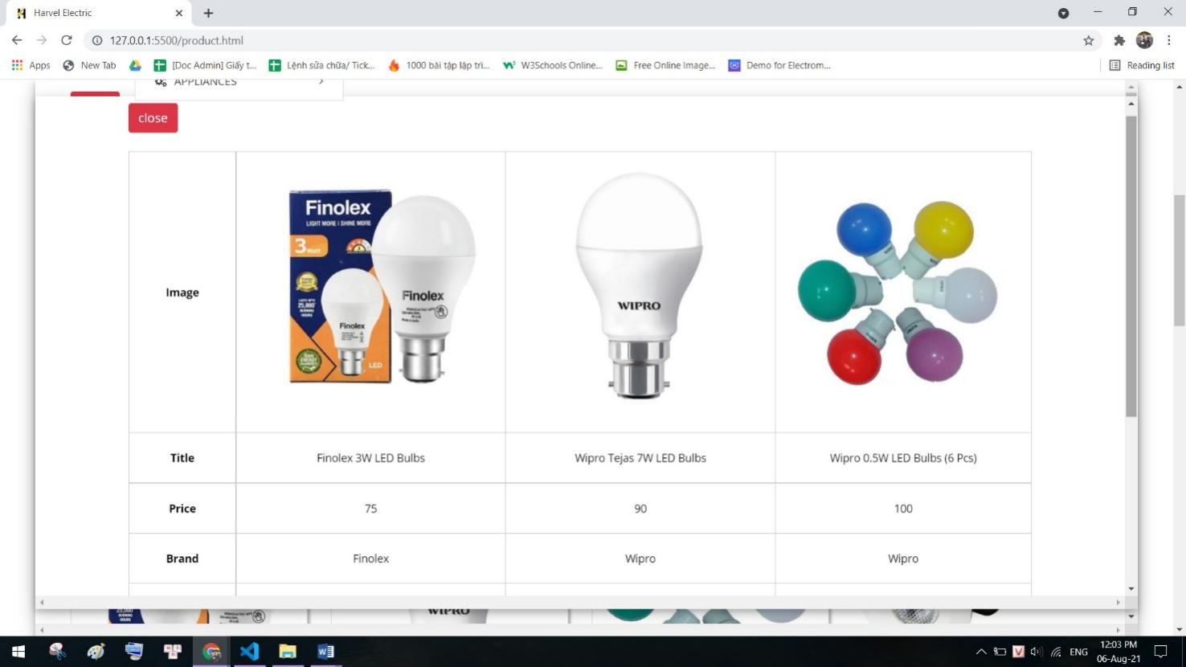

1. **Rainwater Harvesting (Commercial Area):**
2. Description:

The blog page displays following information:

- News.

- Information of product.

- Events, promount.

1. Screen shot:

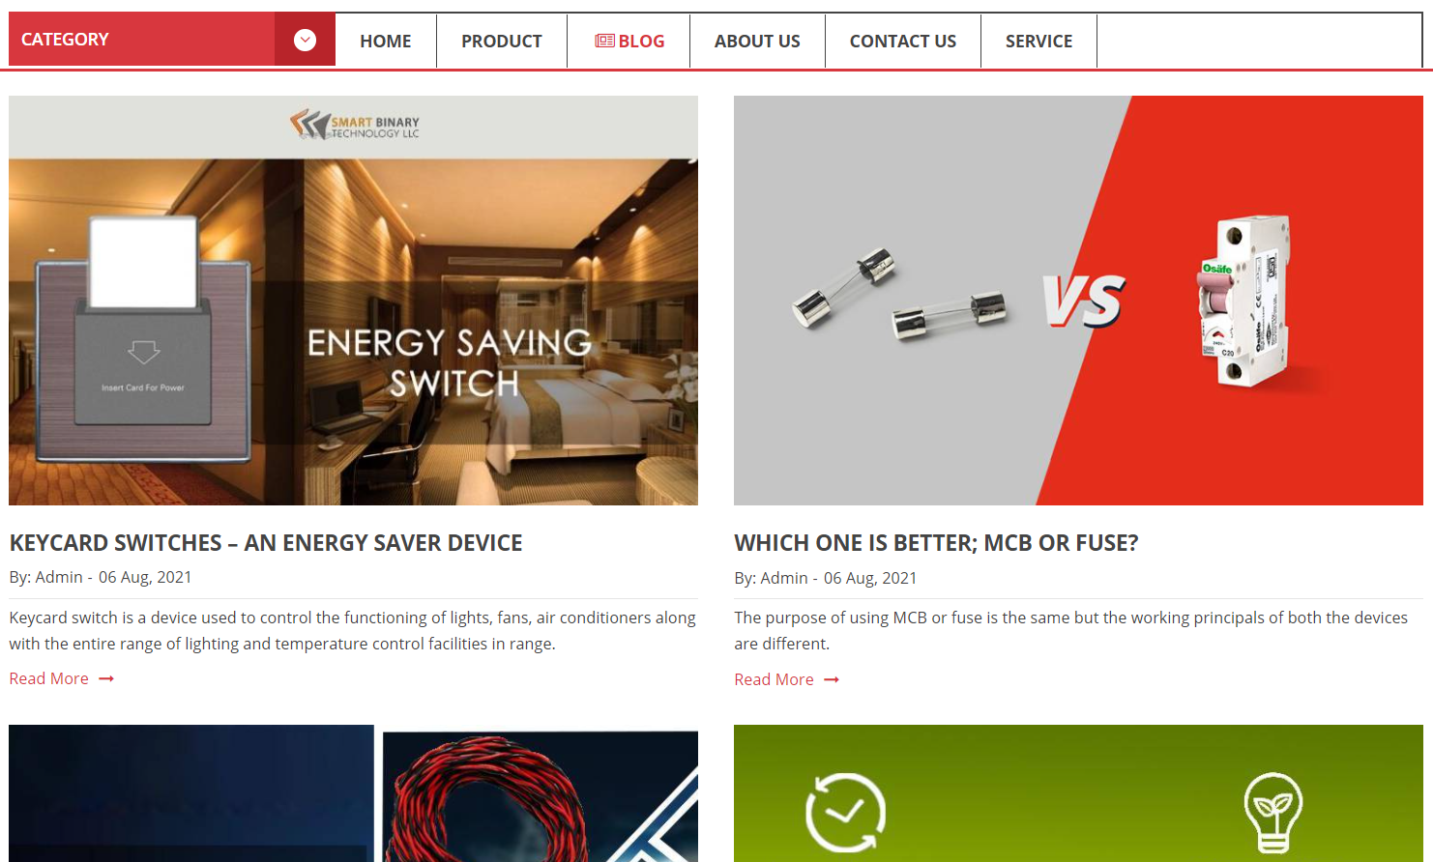



1. **Products:**
2. Description

- This page displays information about the history of Rhythm House, our service that we provide and our team member.

- Display happy customer.

1. Screen shot

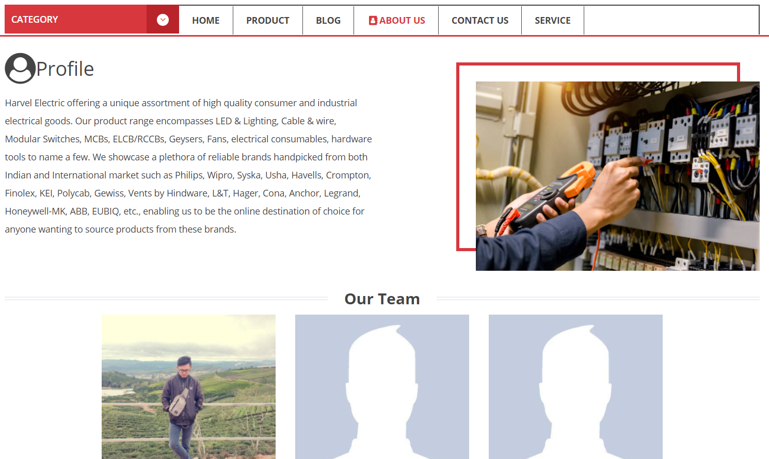



1. **Methods:**
2. Description

This page displays contact information: location, telephone number, email and a quick contact form for customer

1. Screen shot

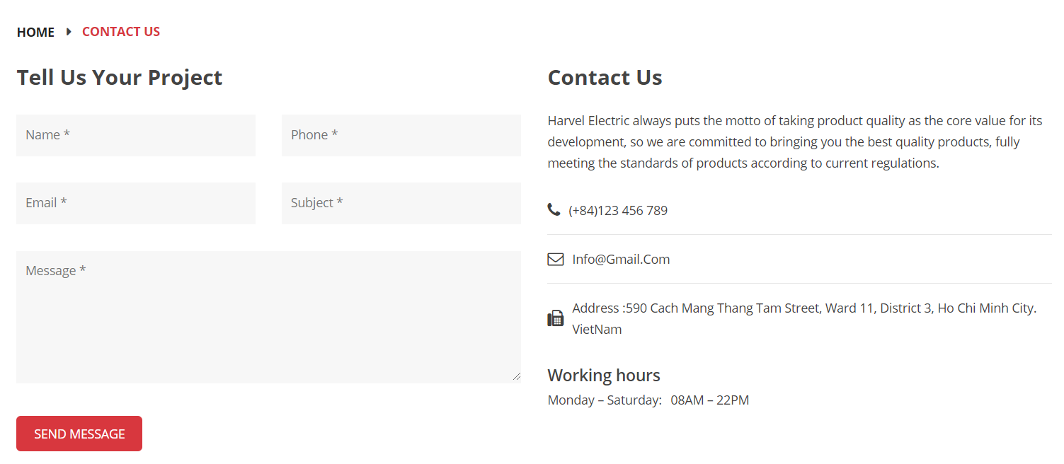

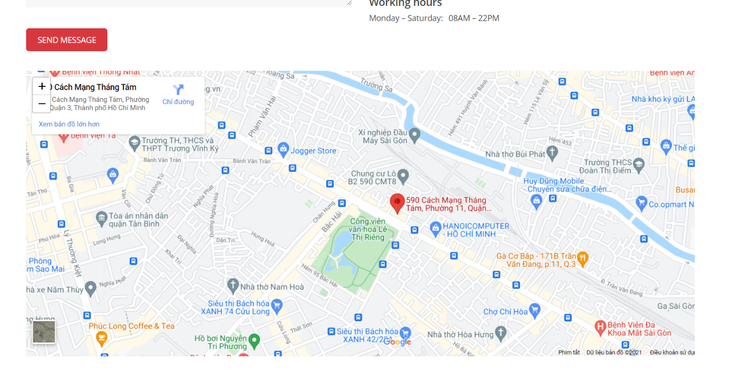

1. **Developments:**
2. Description

- This page displays information: Warranty terms, information, review about product.

- User can download product data.

1. Screen shot

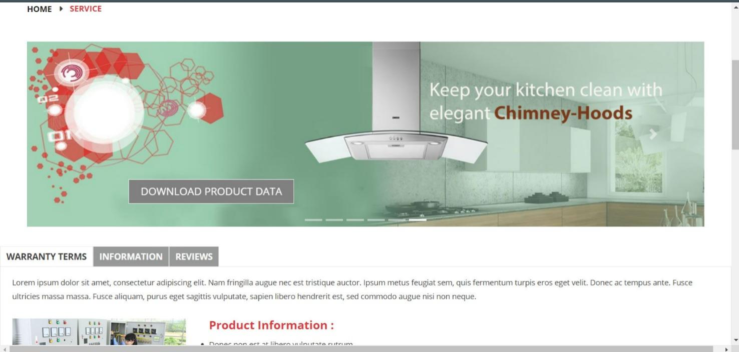

1. **Contact:**
2. Description

- This page displays information: Warranty terms, information, review about product.

- User can download product data.

1. Screen shot

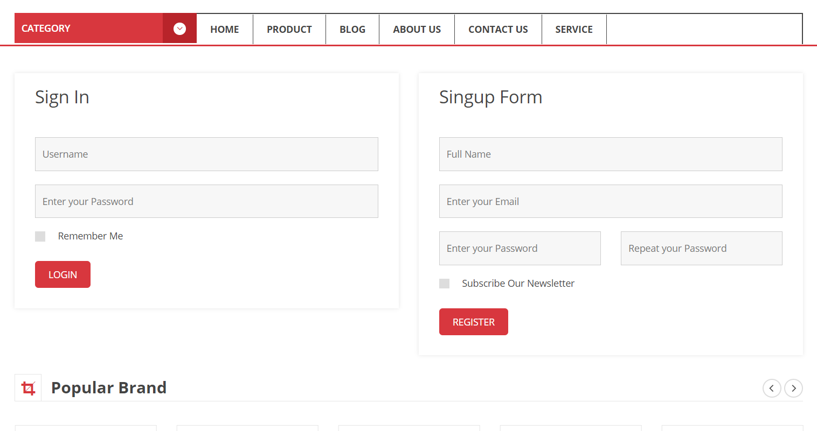

**RESPONSIVE**

The page has responsive feature for small screen device such as smart phone, tablet, etc.

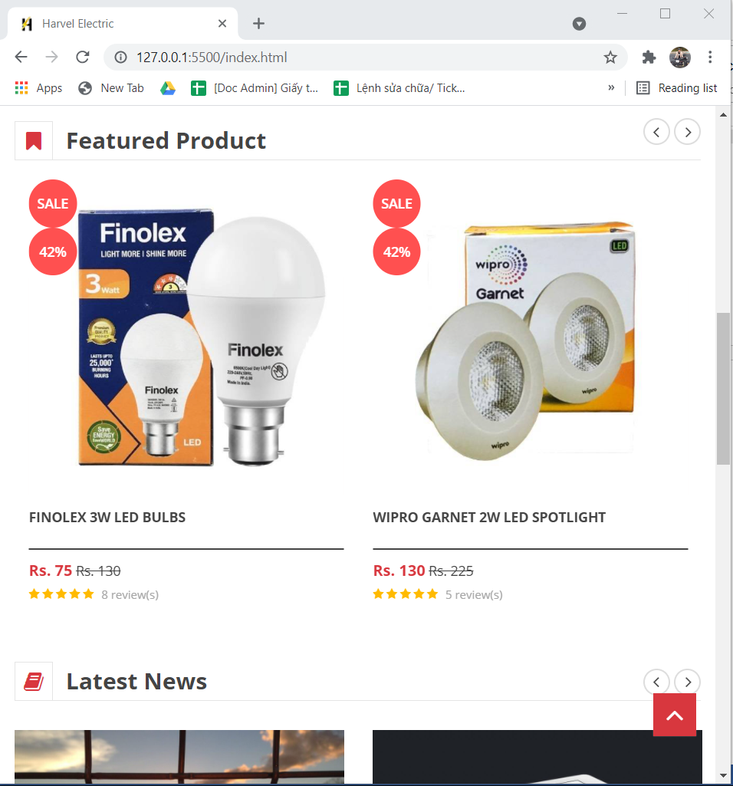

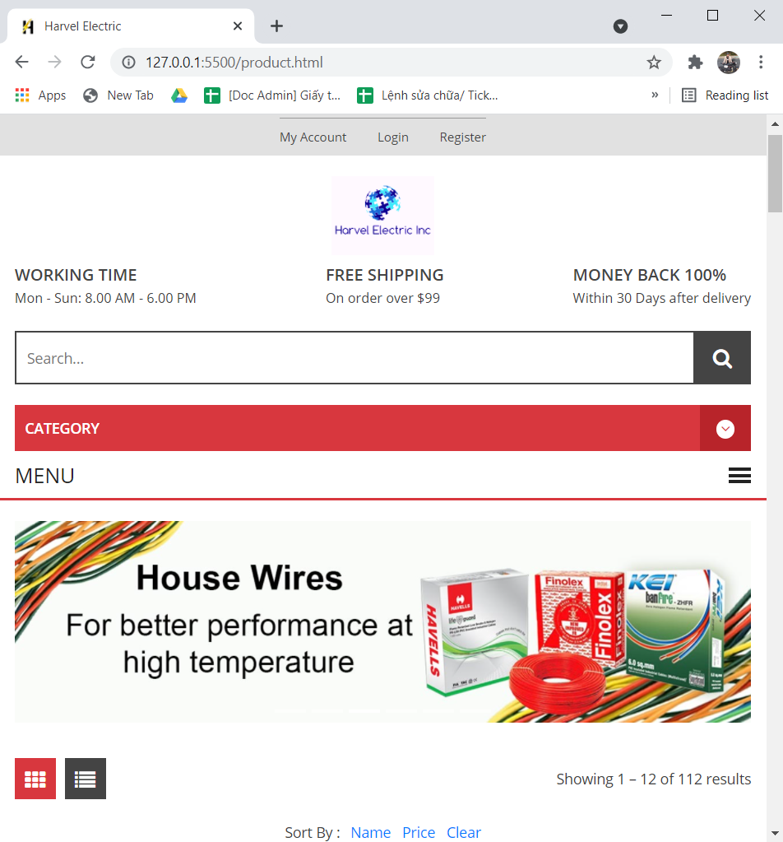

**JAVASCRIPT DESCRIPTION**

1. **Slider Javascript**
2. Description

This script used slick package (carousel) to display the products on the website.

1. Screen shot

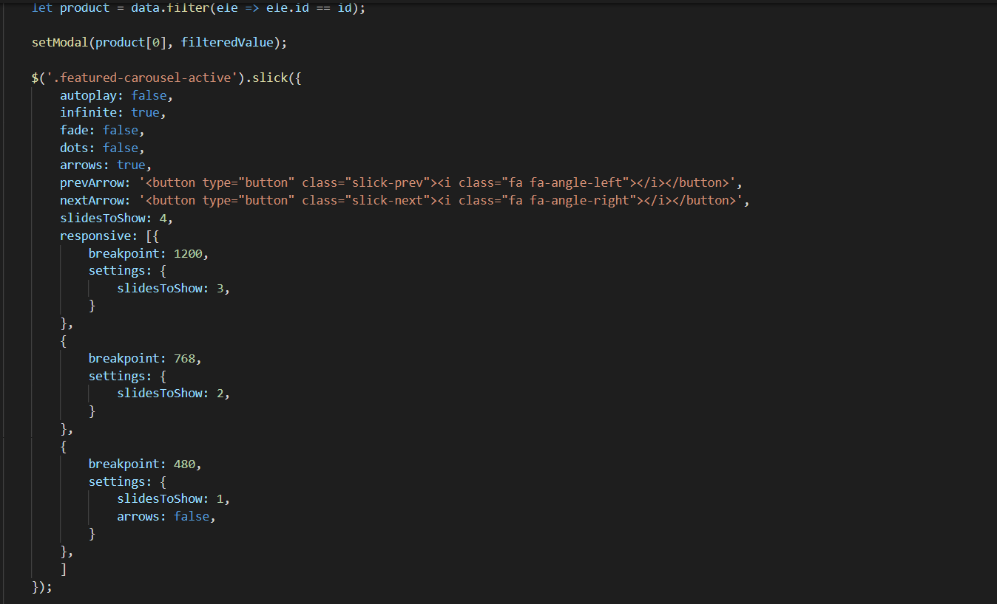

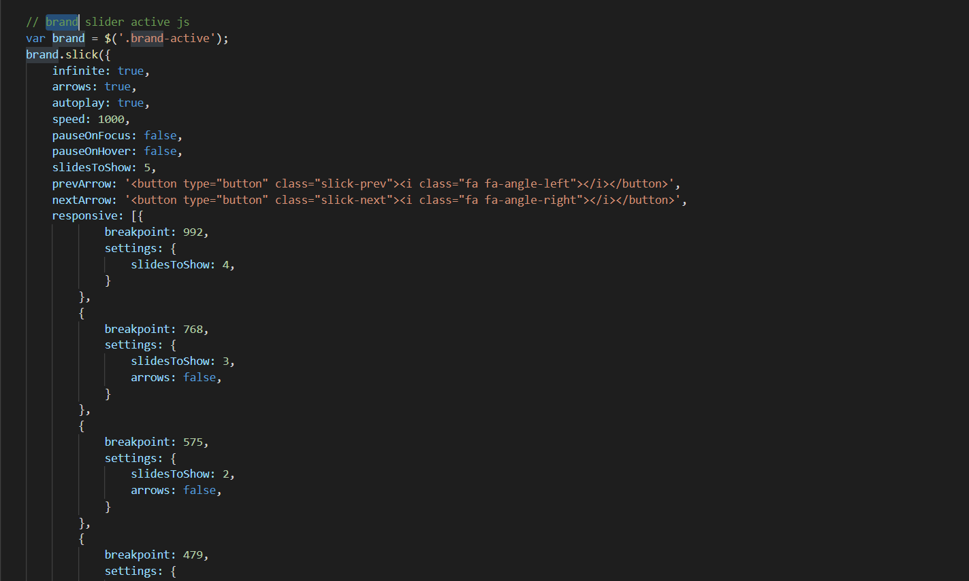

1. **Filter Javascript**
2. Description

This script is used to filter the product list by Type, Brand, Feature, Tag.

1. Screen shot

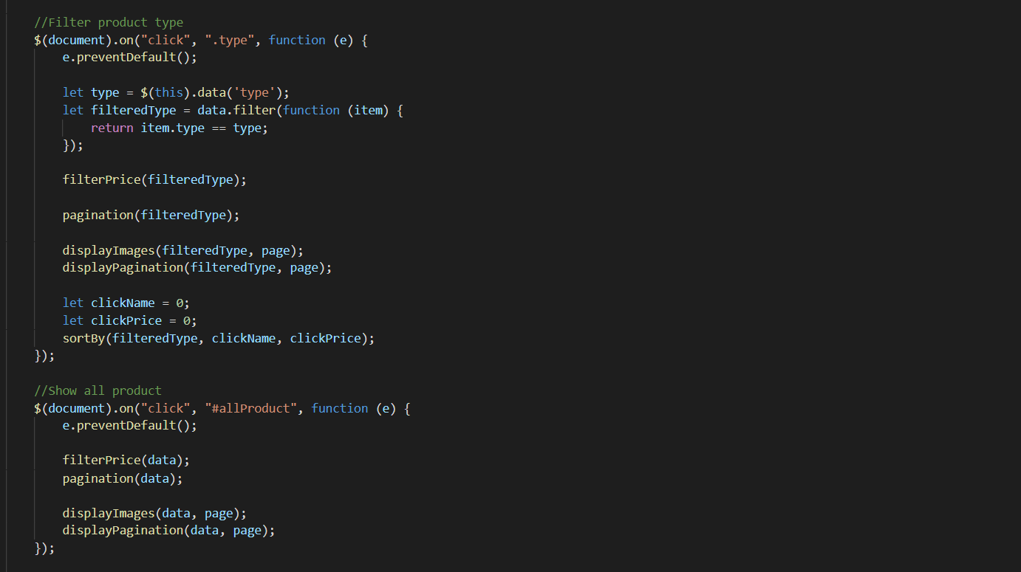

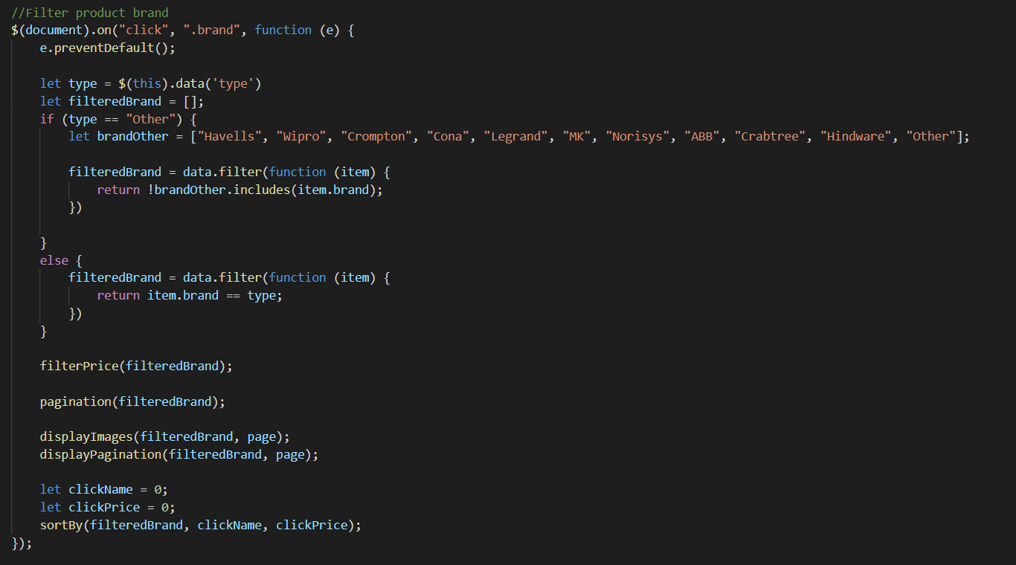

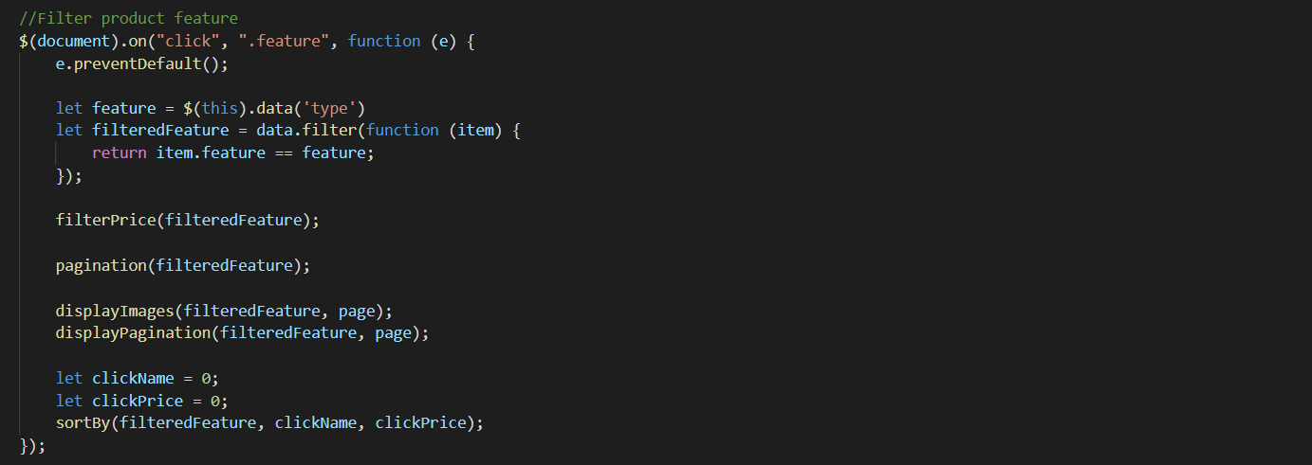

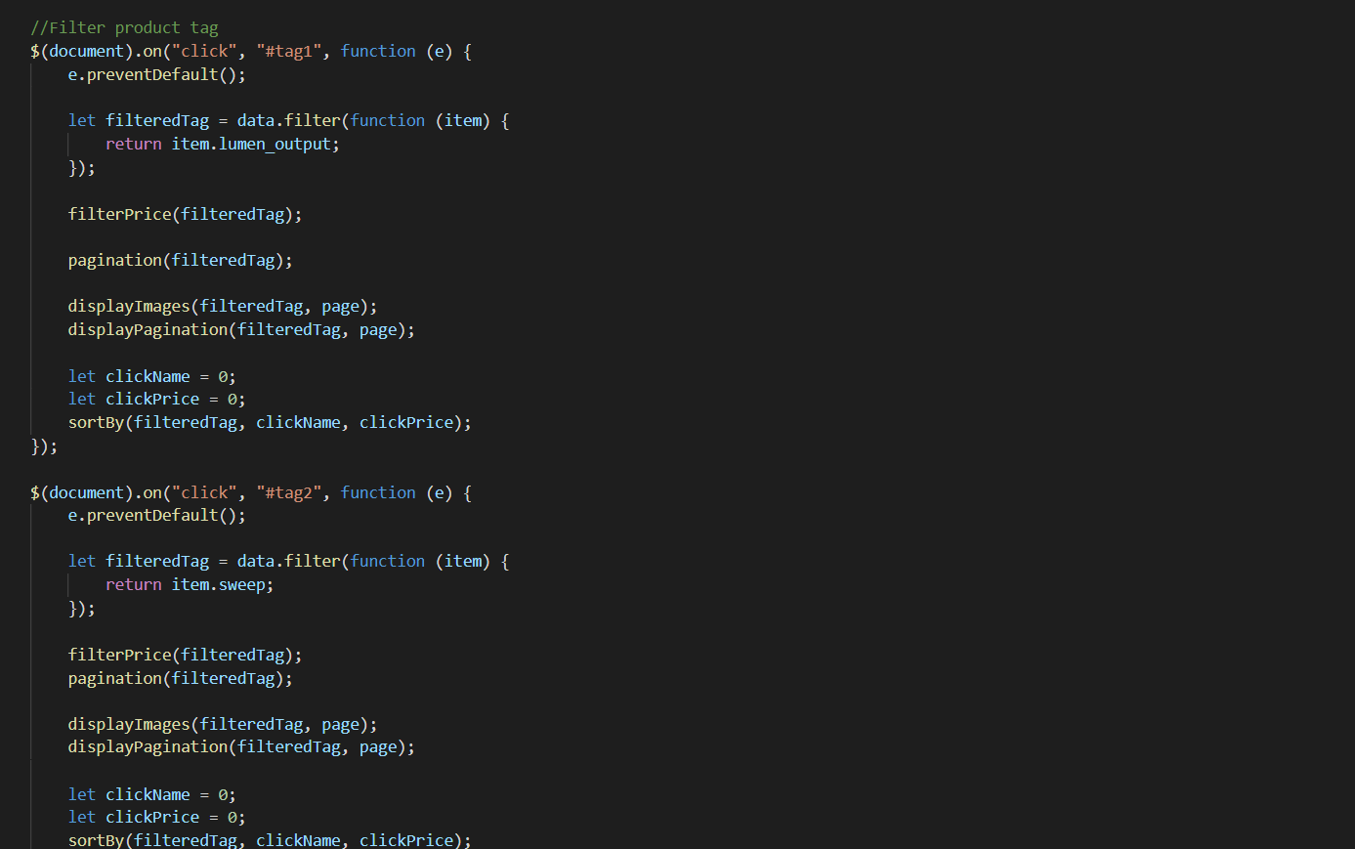

1. **Filter Price Javascript**
2. Description

- This script is used to filter the product list by Price.

- Users can adjust the price to filter products in the selected price bracket

1. Screen shot

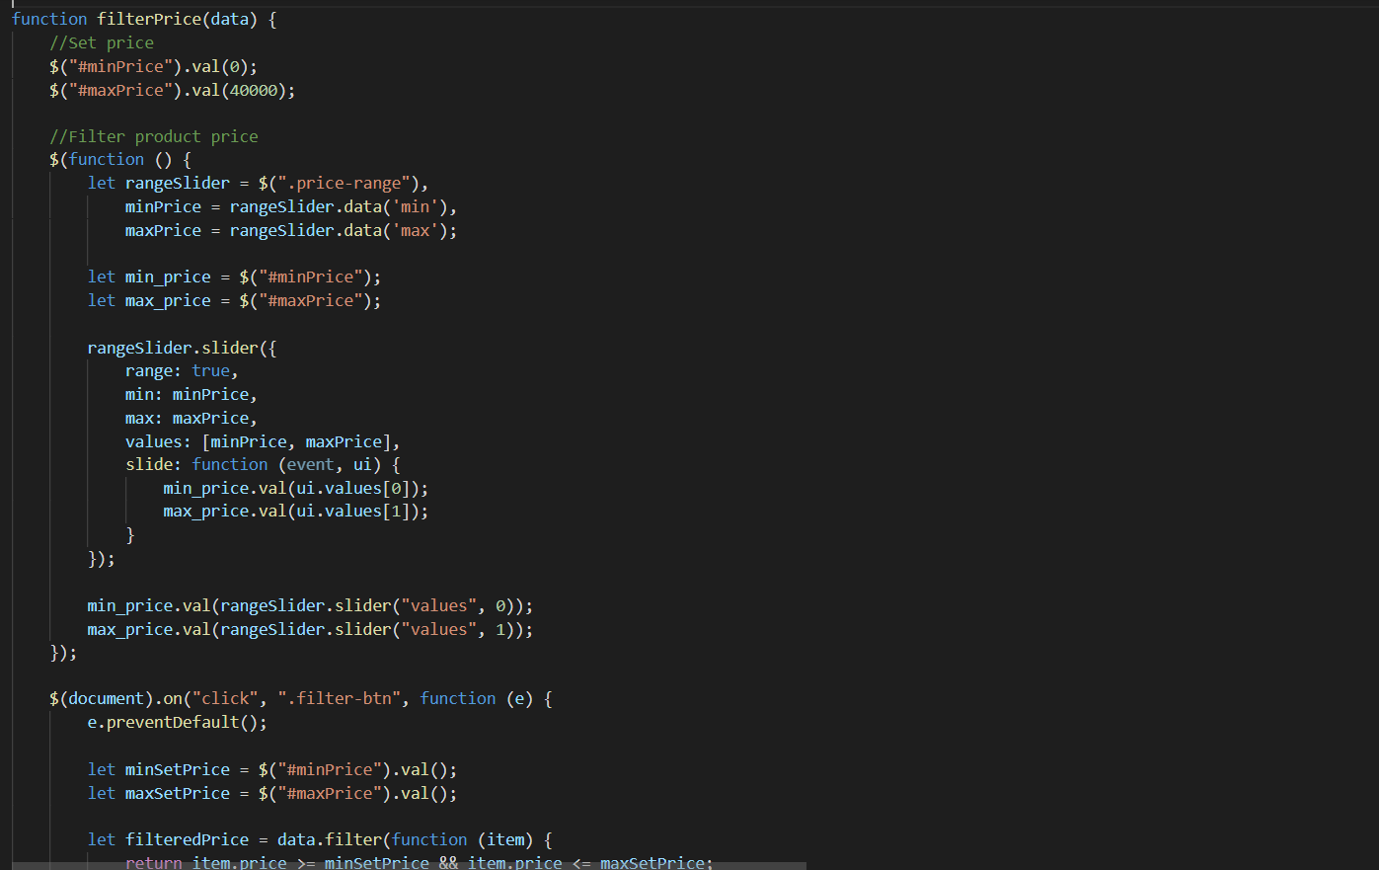

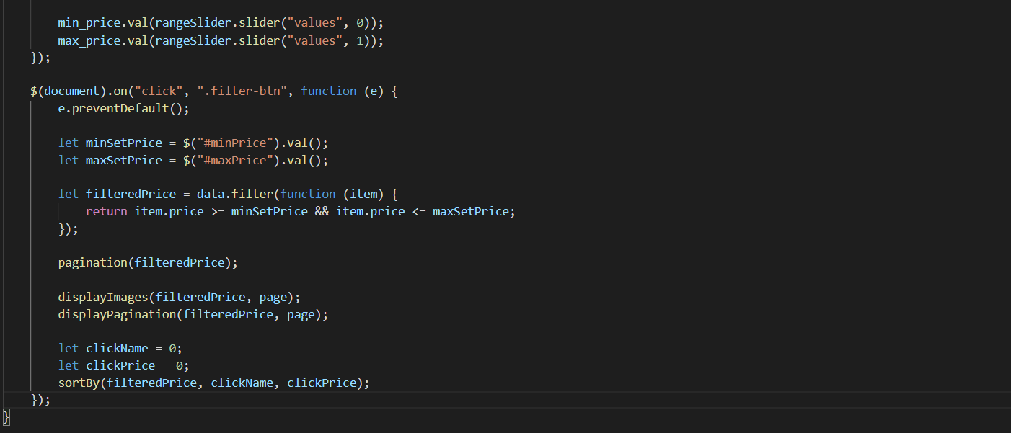

1. **Sort Javascript**
2. Description

This script is used to filter products by name or by price

1. Screen shot

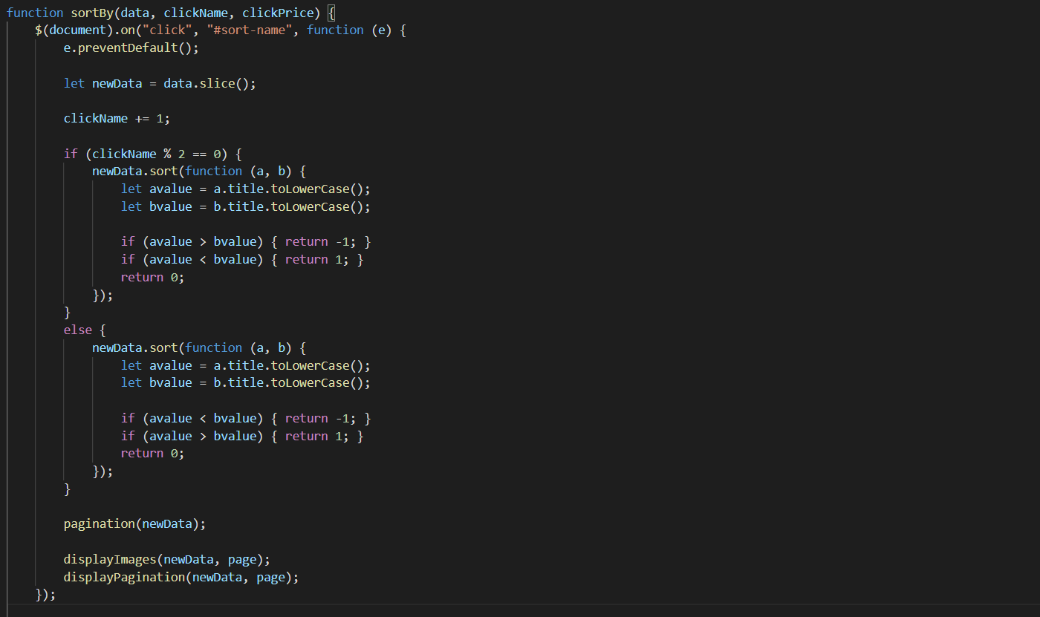

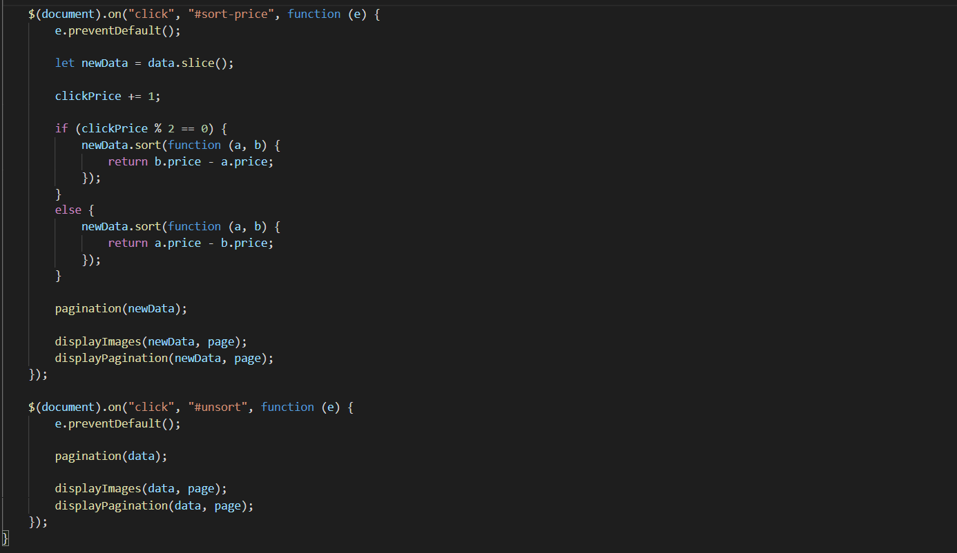

1. **Compare Javascript**
2. Description

This script is used to compare products of the same category

1. Sreen shot

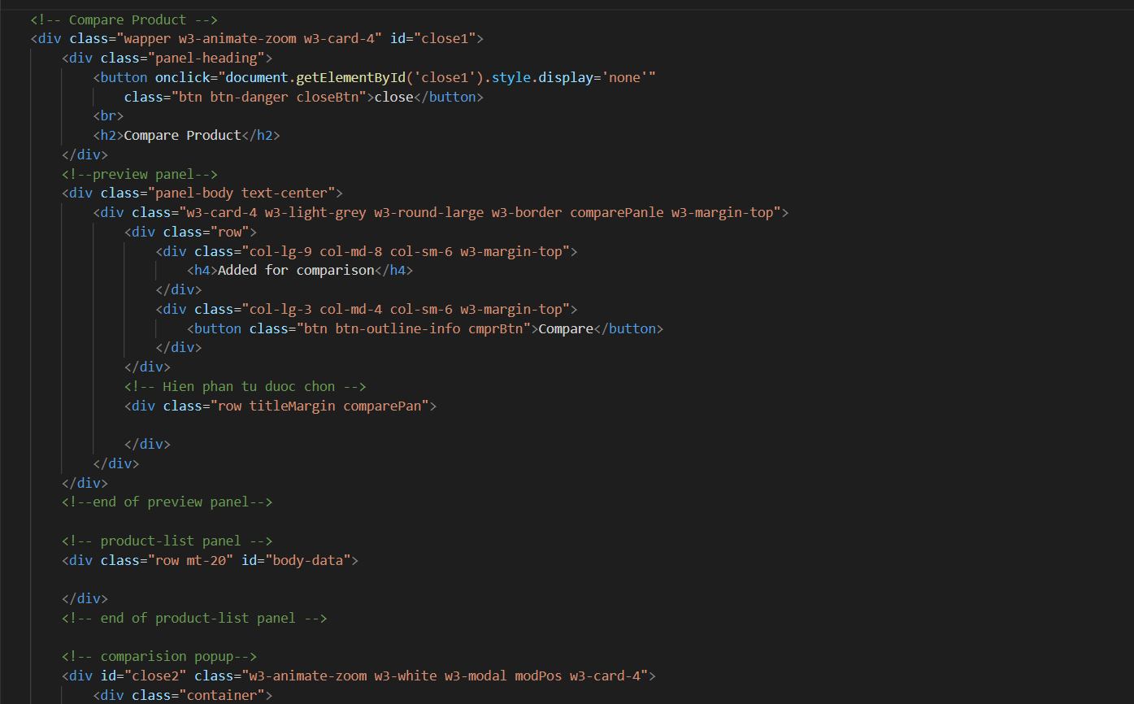

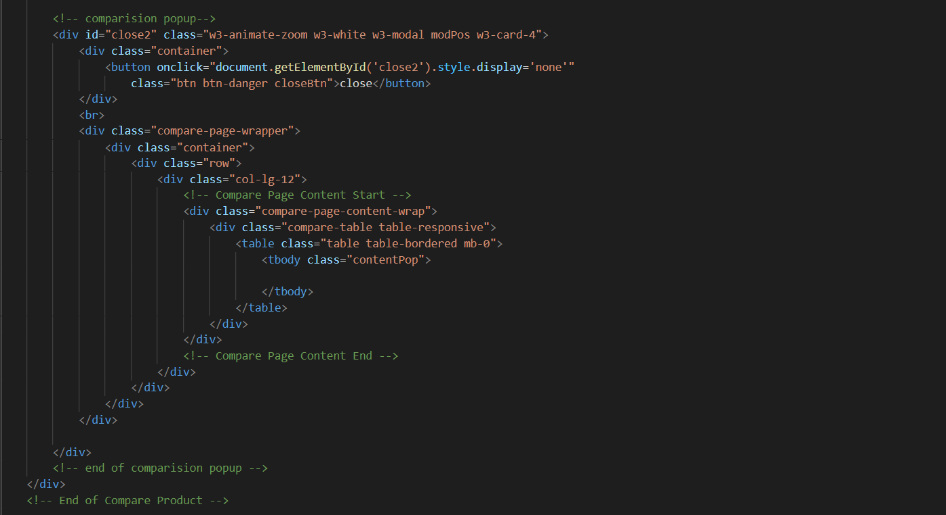

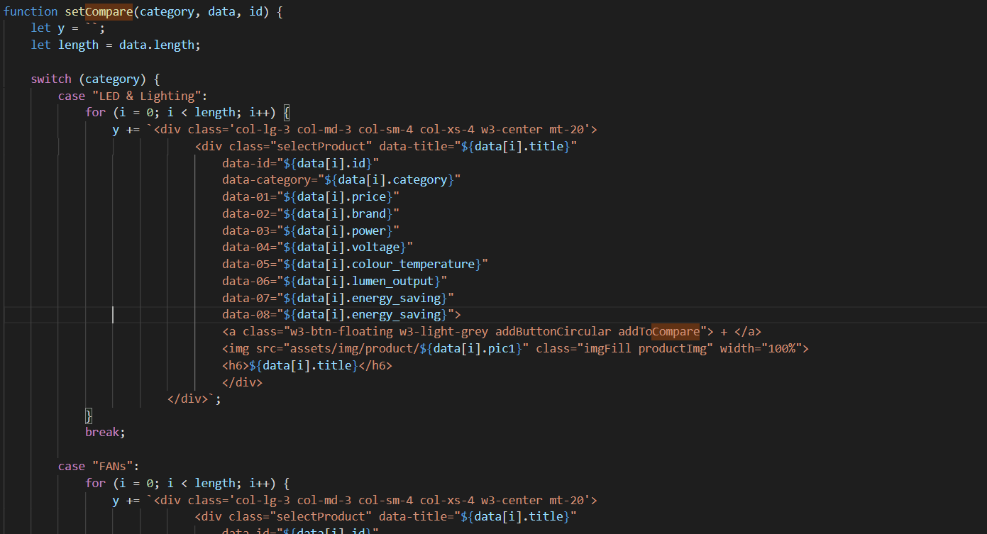

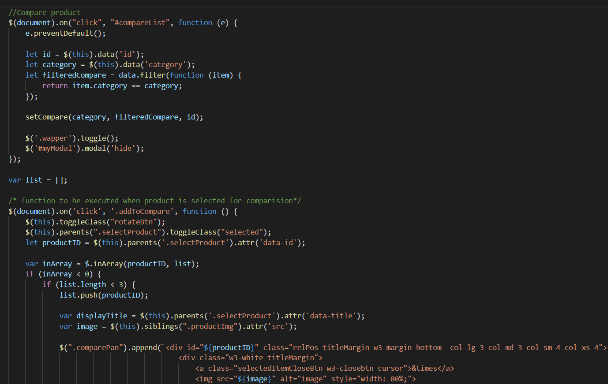

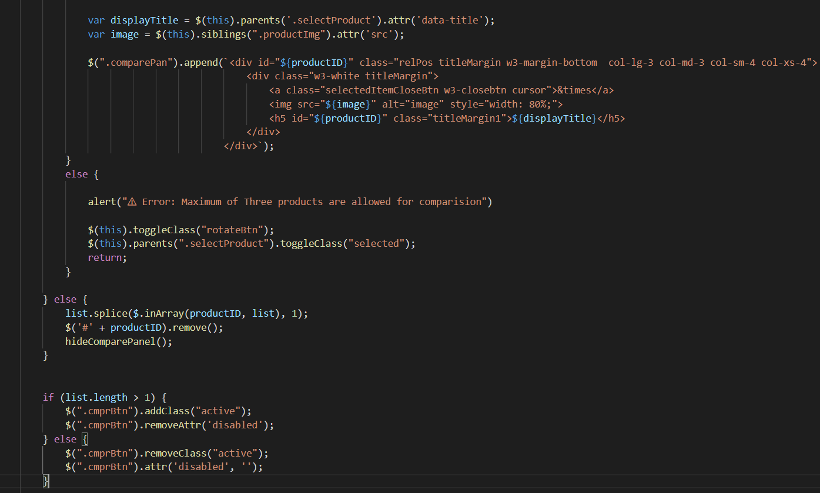

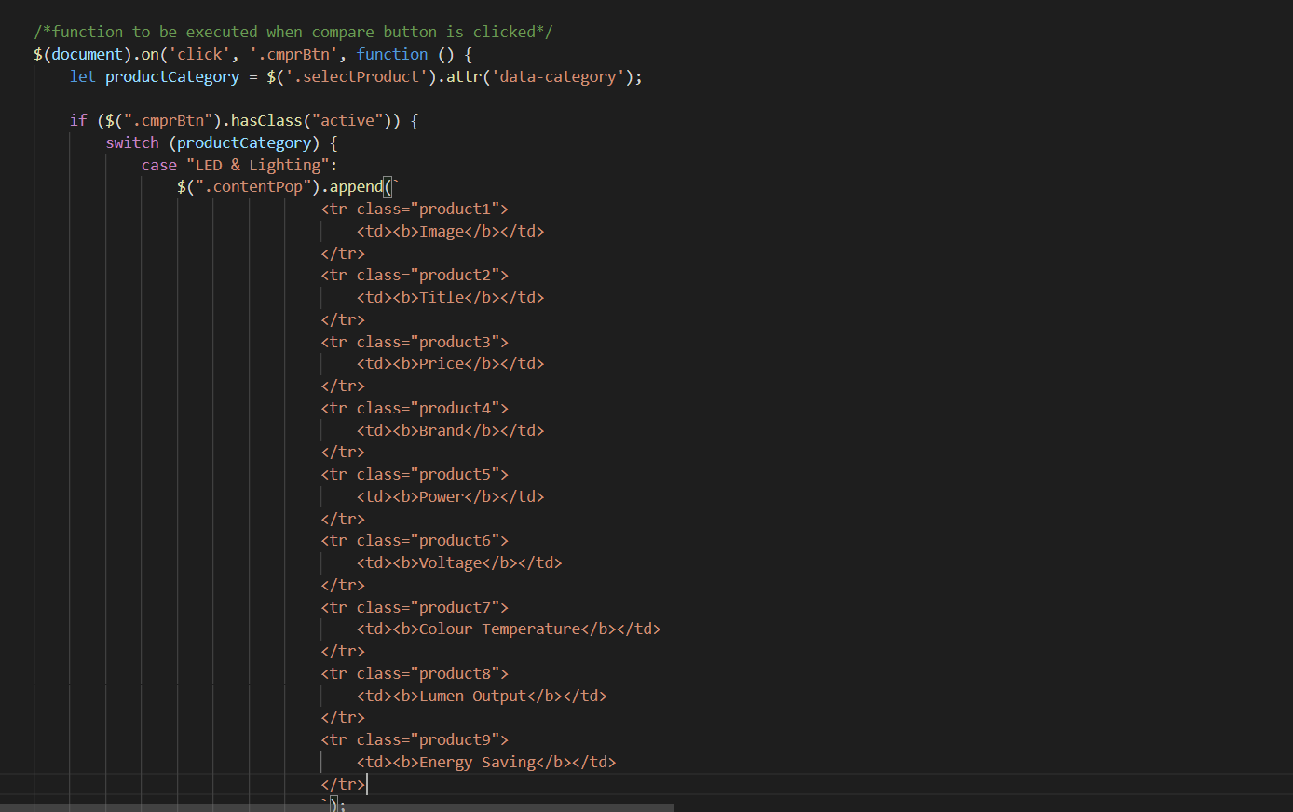

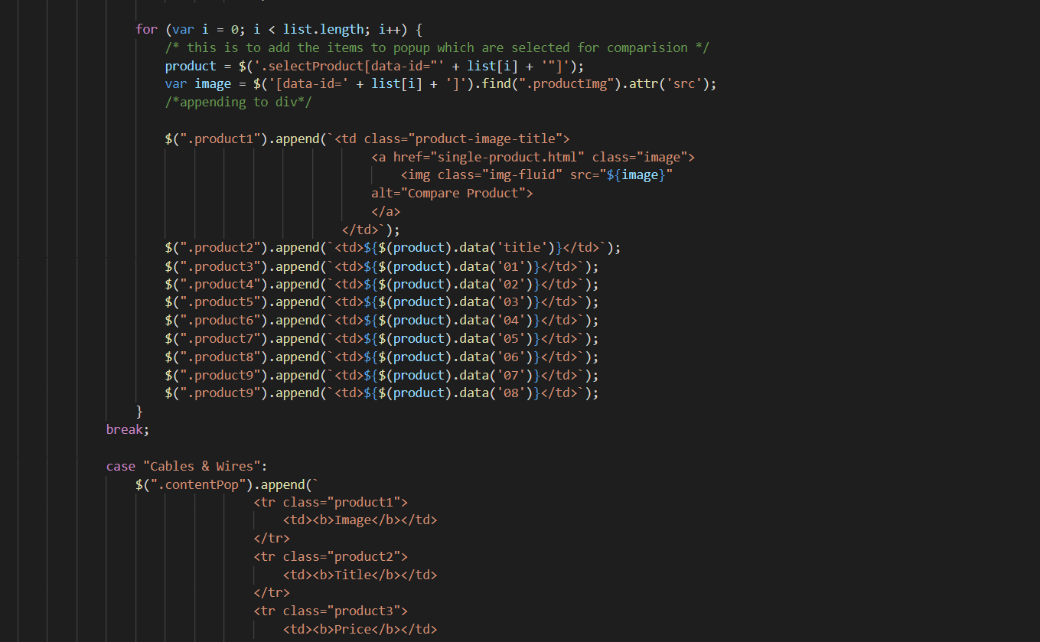

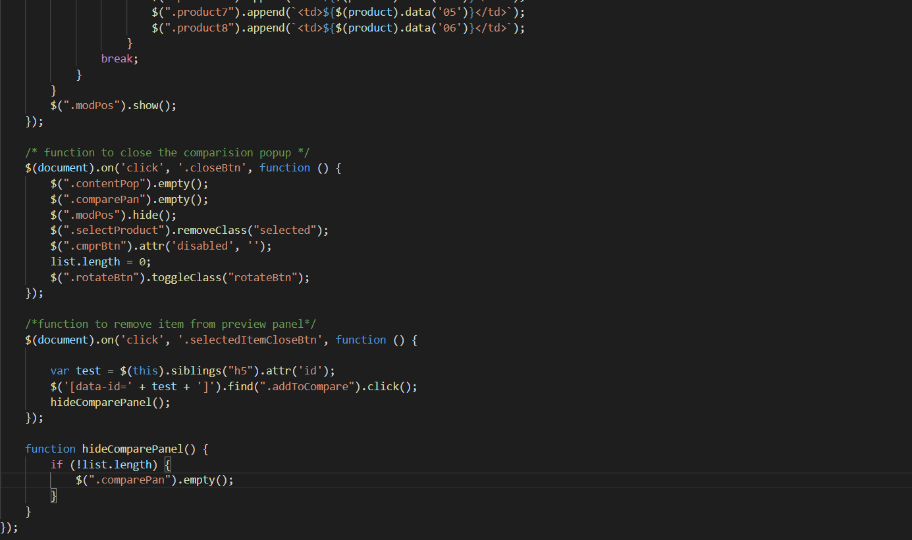

1. **Pagination Javascript**
2. Description

This script is used to paginate products into pages, each with twelve products

1. Sreen shot

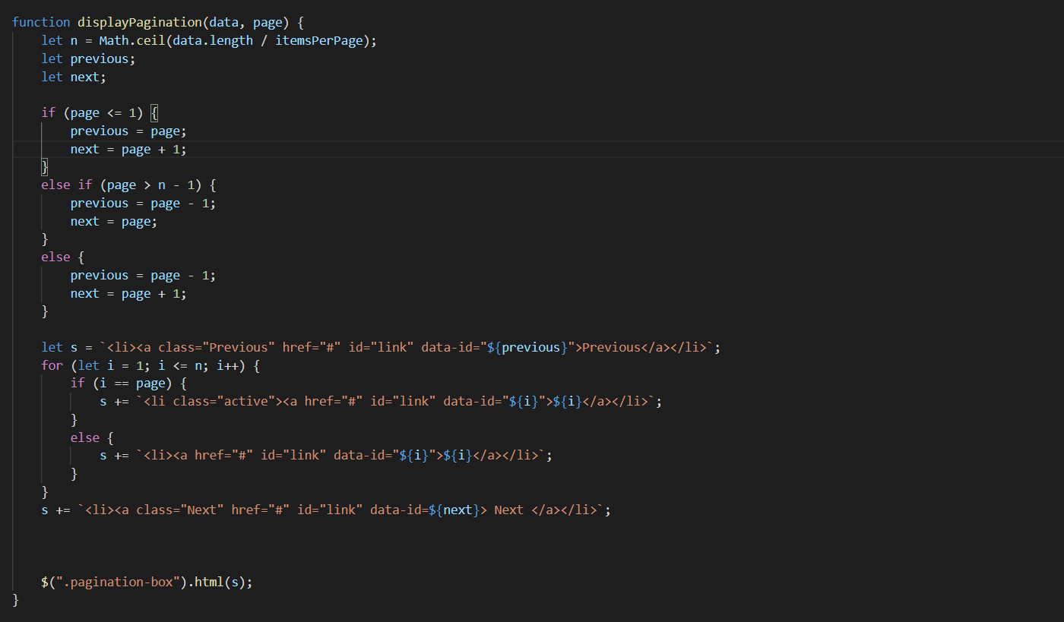

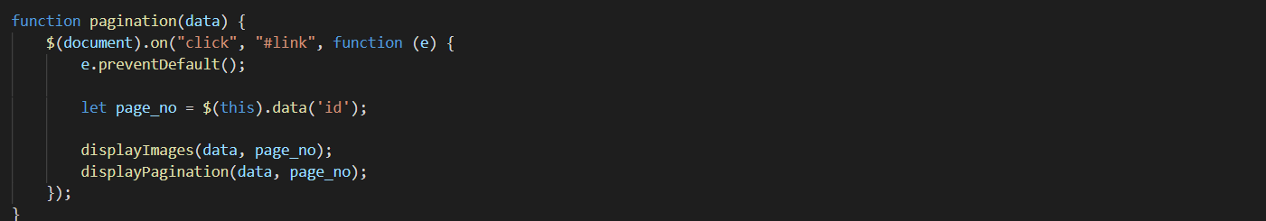

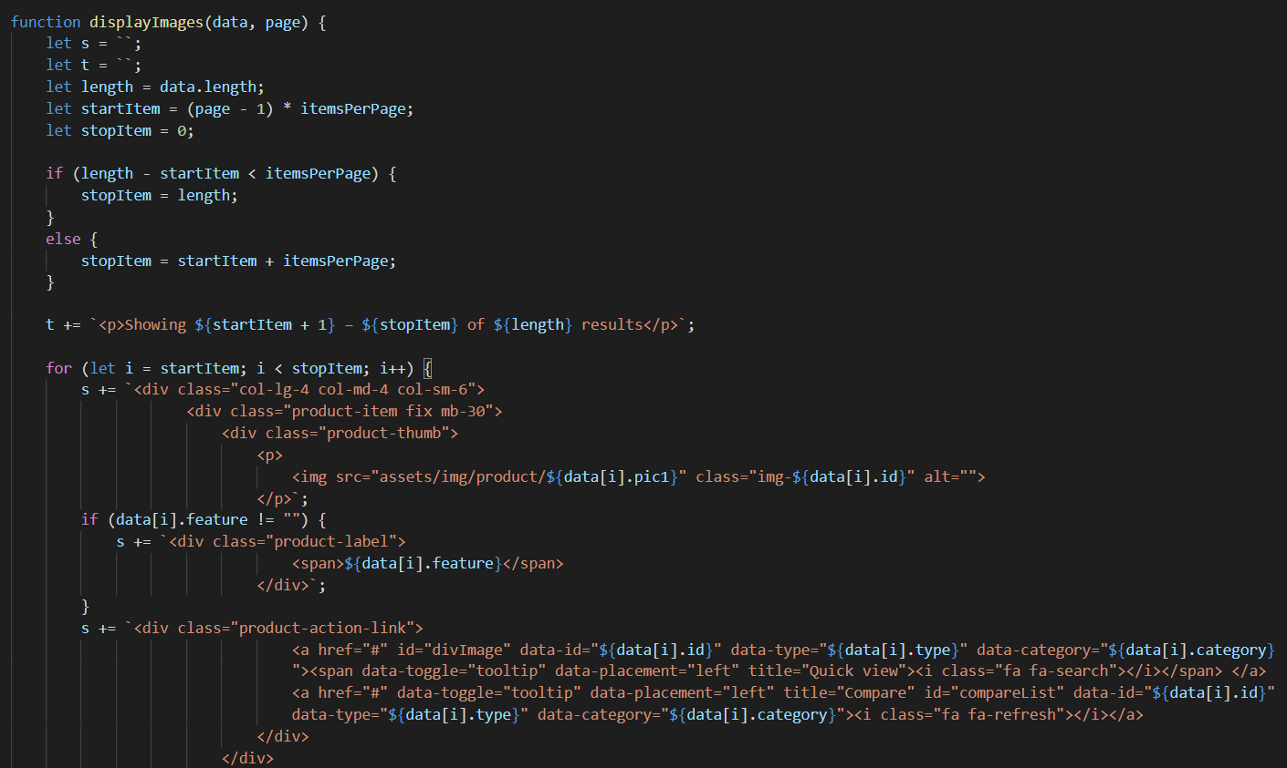

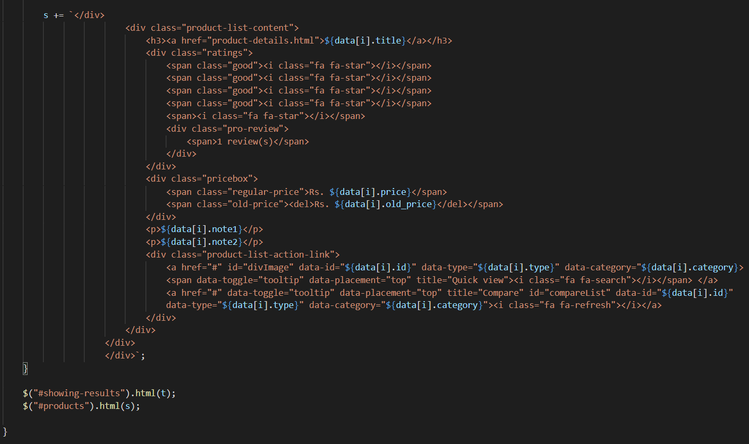

1. **Create Modal Javascript**
2. Description

This script is used to display product details in a modal format. Inside there are more products of the same type

1. Screen shot

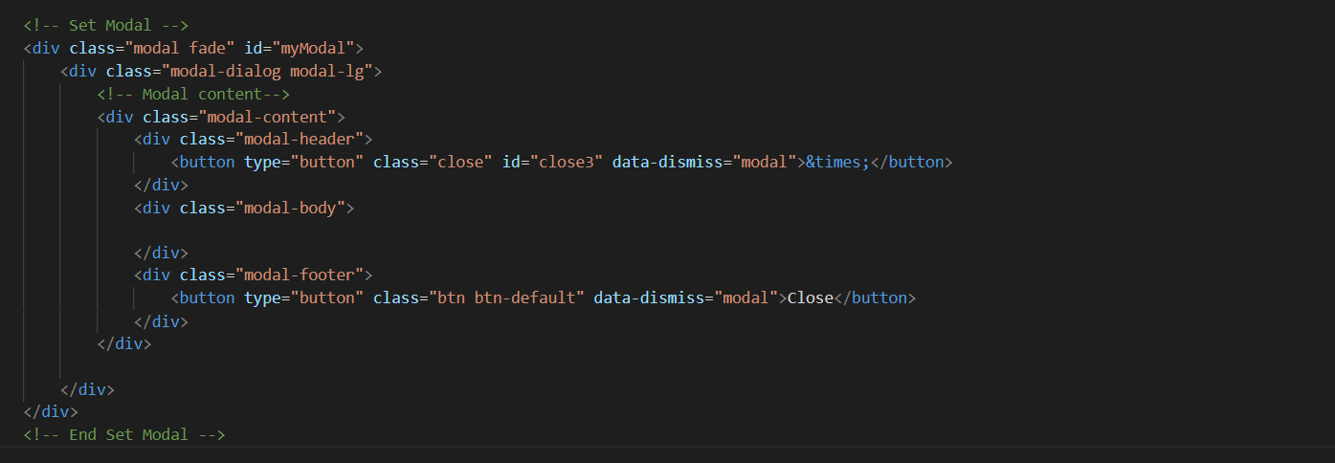

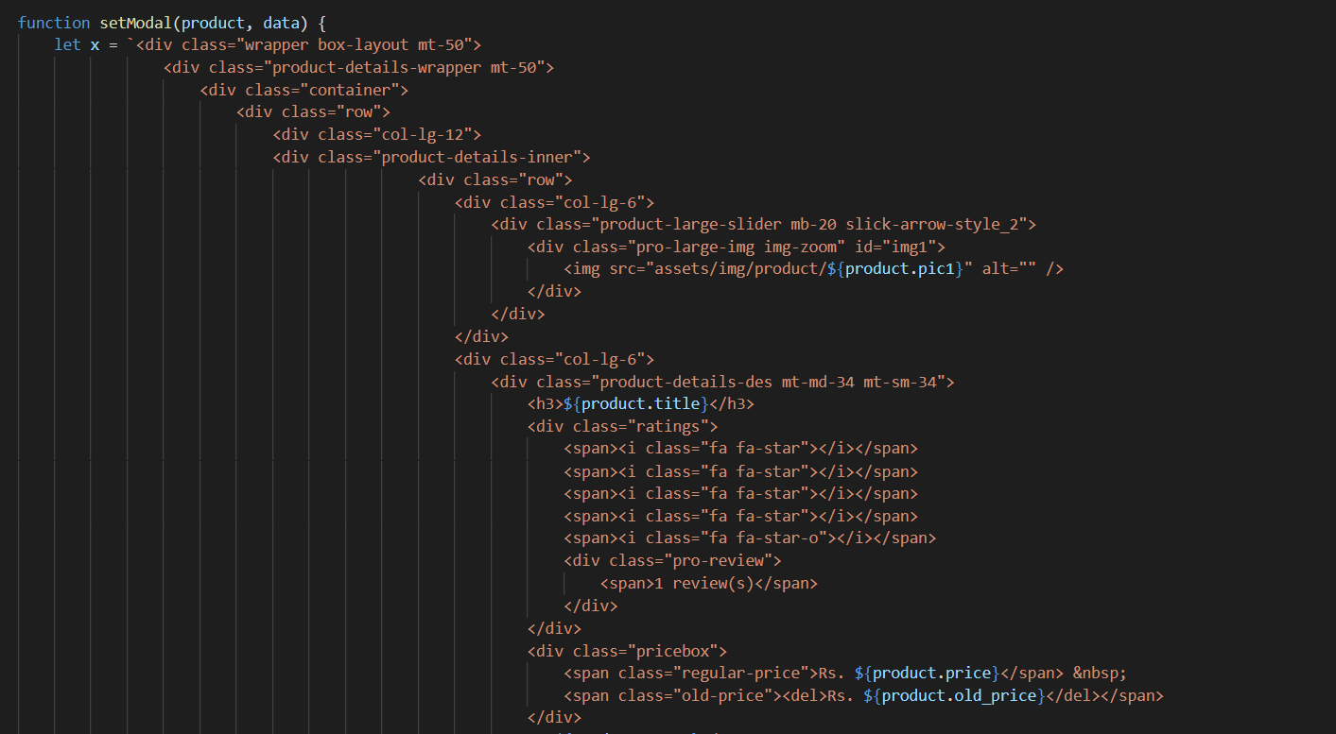

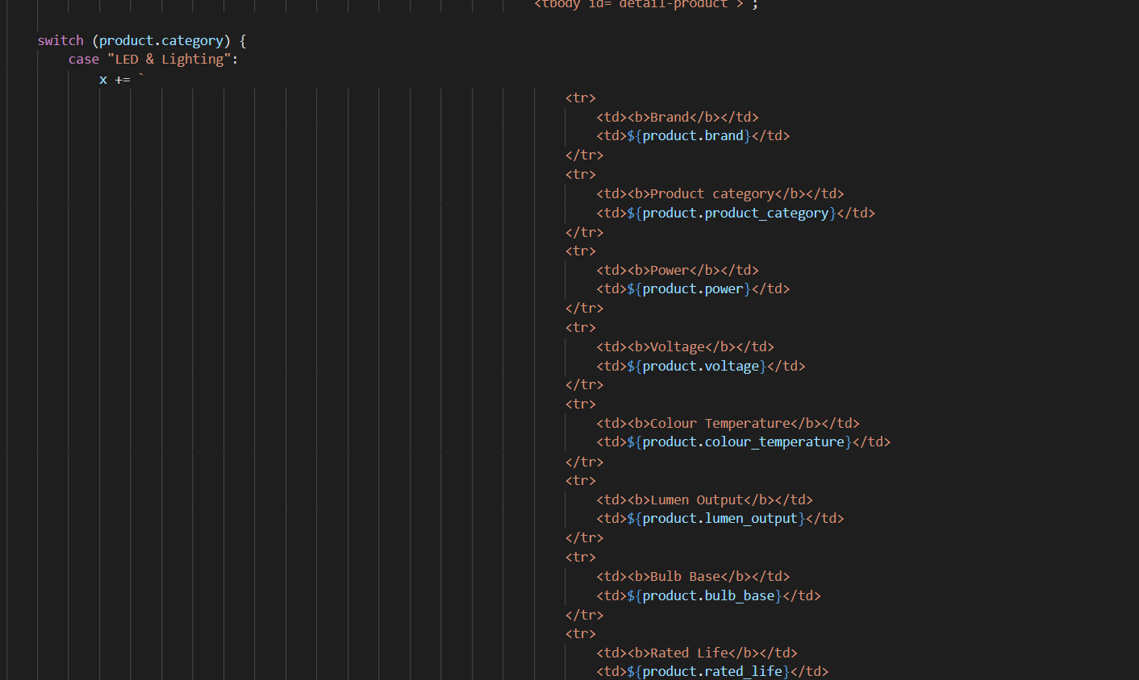

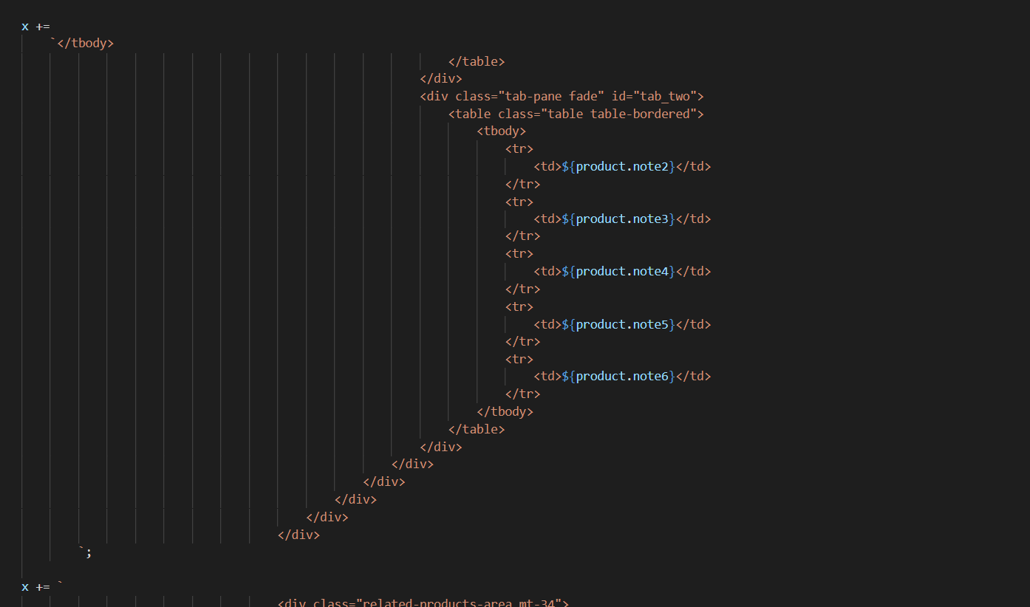

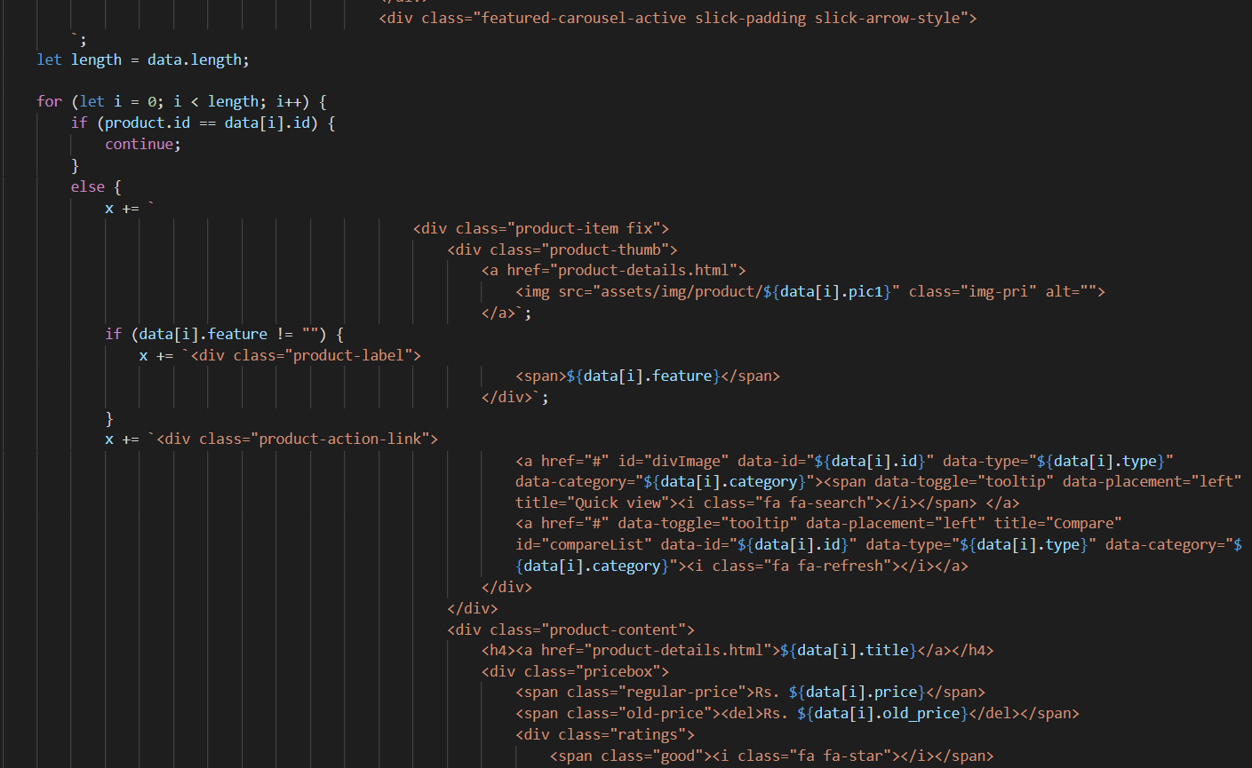

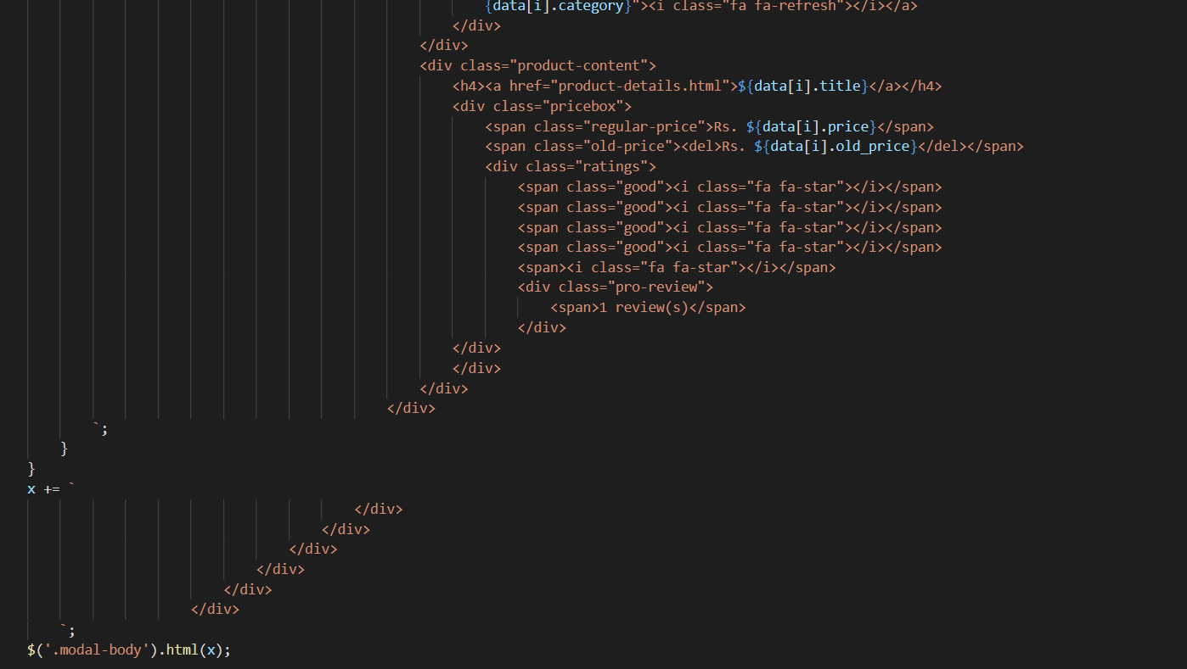

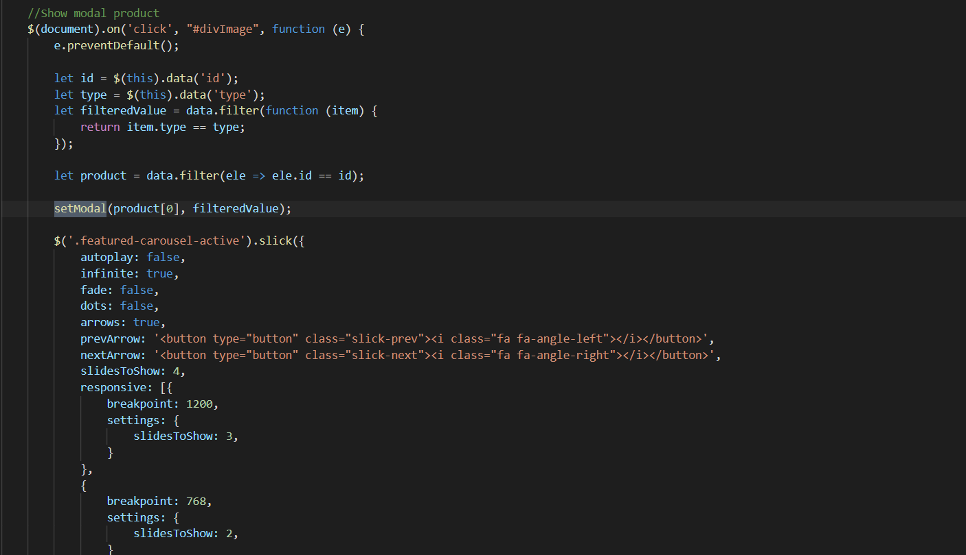

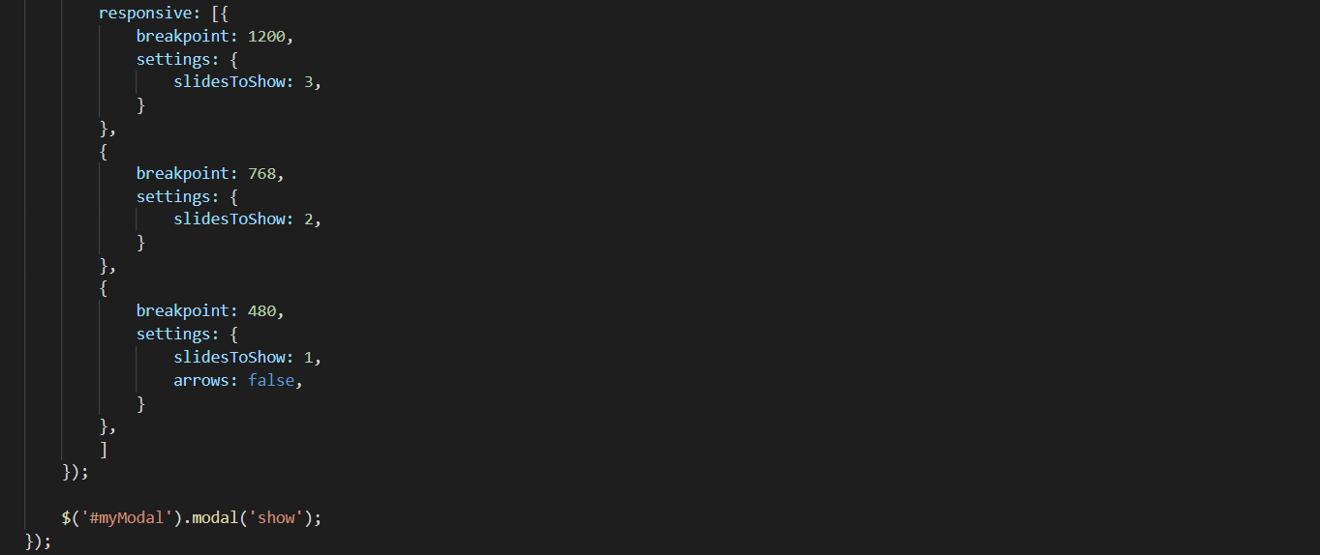

1. **Show number of product Javascript**
2. Description

This script is used to display the number of products by type, brand and feature

1. Screen shot

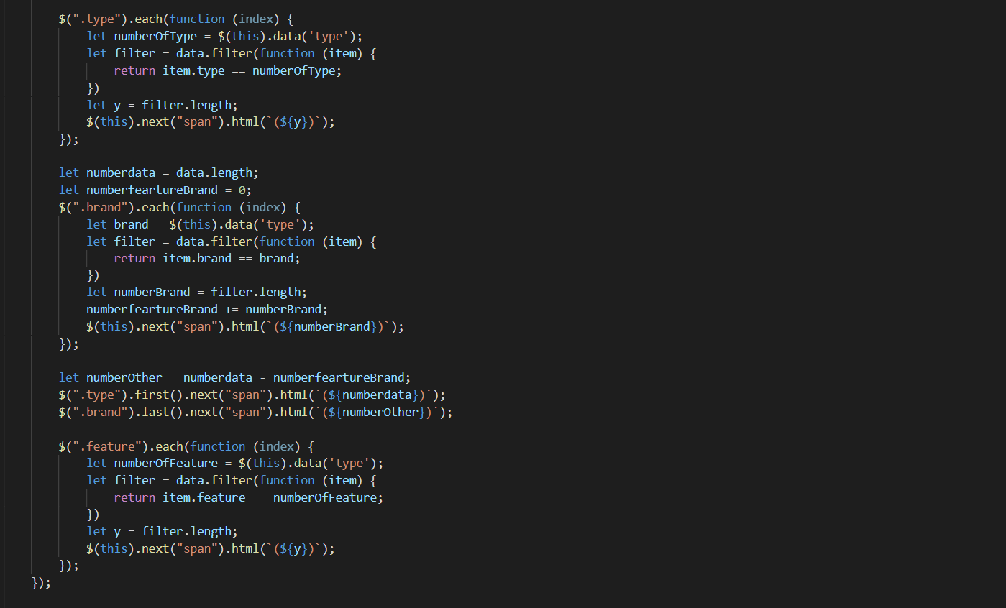

1. **Sign-in & Sign-up Javascript**
2. Description

This script used for member registration and login in the website.

1. Screen shot

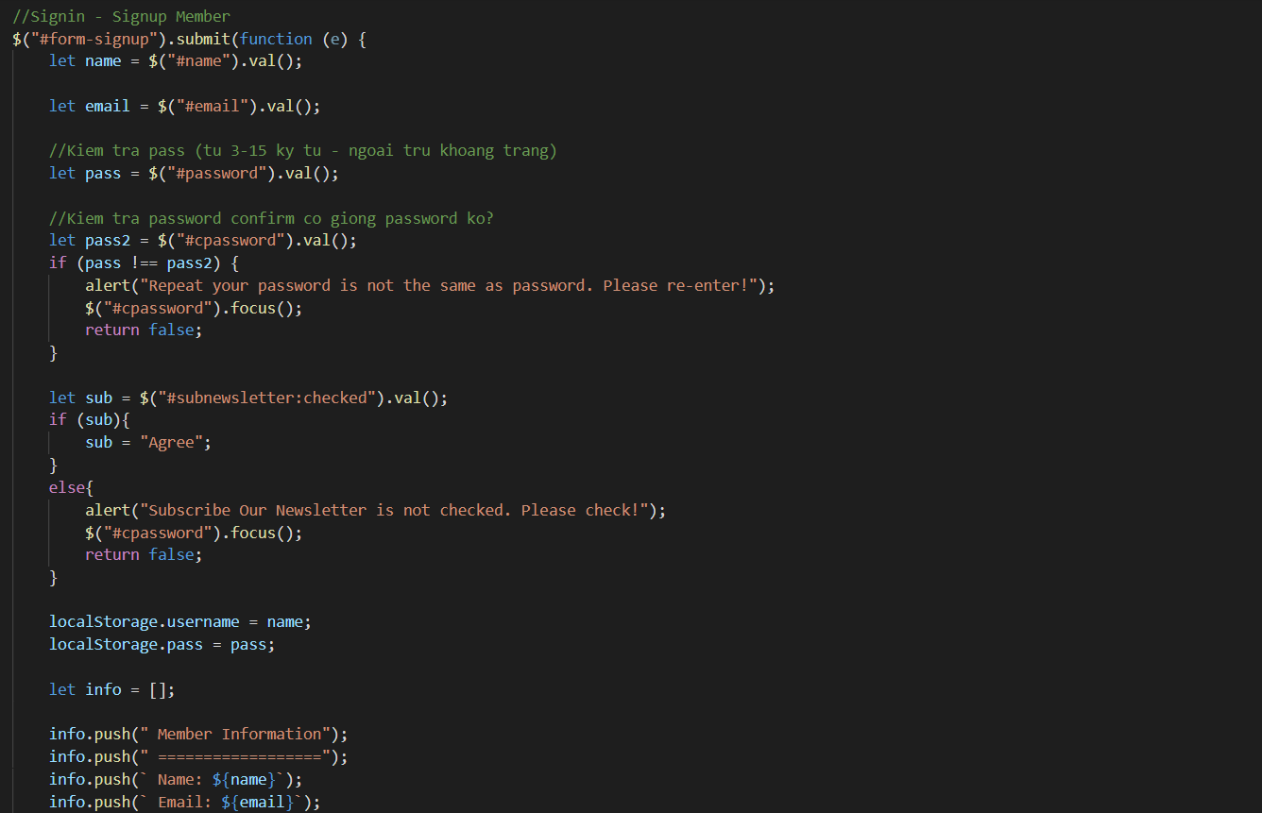

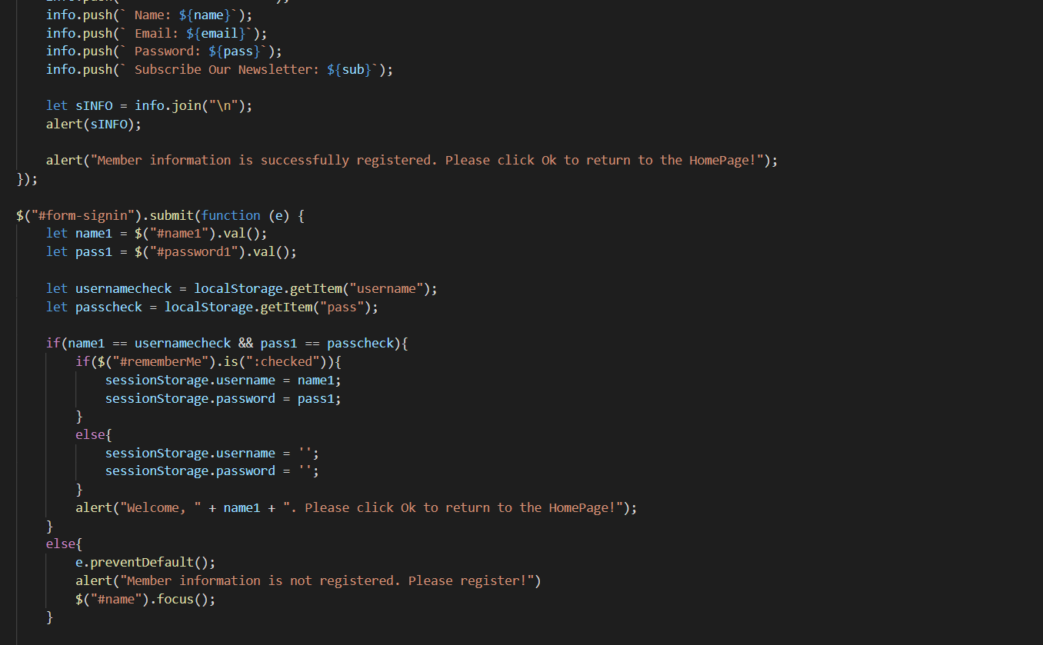

# TASK SHEET REVIEW 3

|  |  |  |  |  |  |  |  |
| --- | --- | --- | --- | --- | --- | --- | --- |
| **Project Ref. No.:**  **eP/Advertisement Portal Management**  **System/01** | | **Project Title:** | **Activity Plan Prepared By:** | **Date of Preparation of Activity Plan:** | | | |
| **Sr.**  **No.** | **Task** | **Actual**  **Start**  **Date** | **Actual Days** | **Team**  **Mate Names** | **Status** |
| 1 | Home Page | RAINWATER HARVESTING | Tu | 18-July-21 | 1 | Dai | Completed |
| 2 | Residential Area | 20-July-21 | 3 | Dai | Completed |
| 3 | Commercial Area | 18-July-21 | 2 | Dung | Completed |
| 4 | Methods | 20-July-21 | 2 | Dung | Completed |
| 5 | Developments | 18-July-21 | 2 | Thanh | Completed |
| 6 | Contact | 20-July-21 | 2 | Thanh | Completed |
| 8 | Java Script | 23-July-21 | 2 | Dai | Completed |

|  |  |
| --- | --- |
| **Date:** | |
| Signature of Instructor:  **Ms. Le Mong Thuy** | Signature of Team Leader:  **Tran Hong Duy Tu** |